## 

# RC-PC

### Name: Thomas Gymer

### Candidate number: 4552

### Centre number: 66643

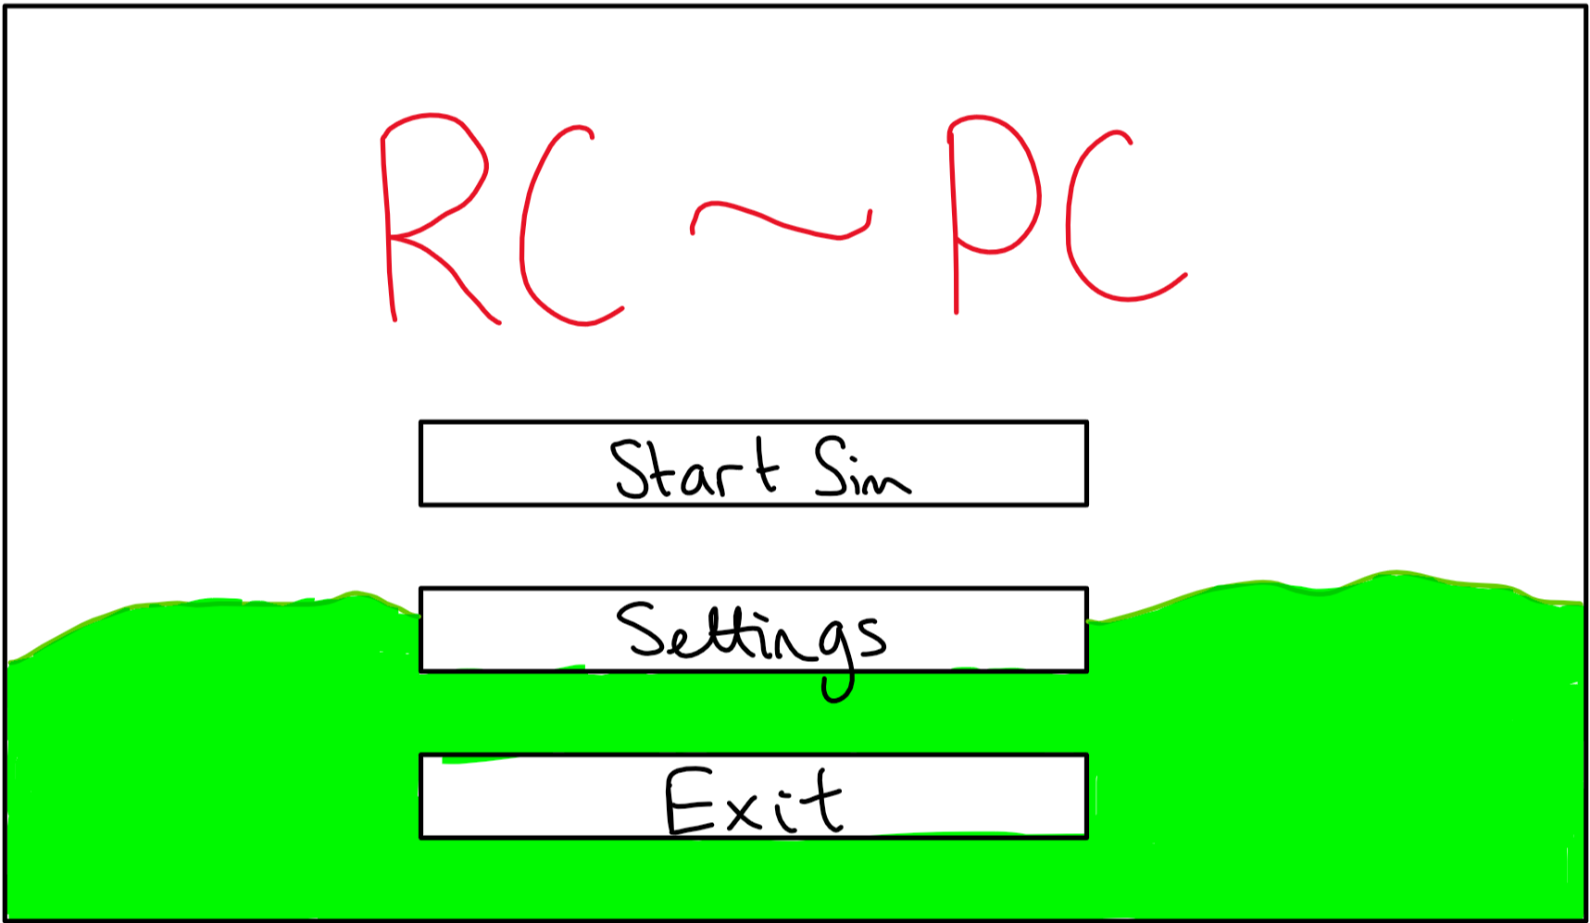

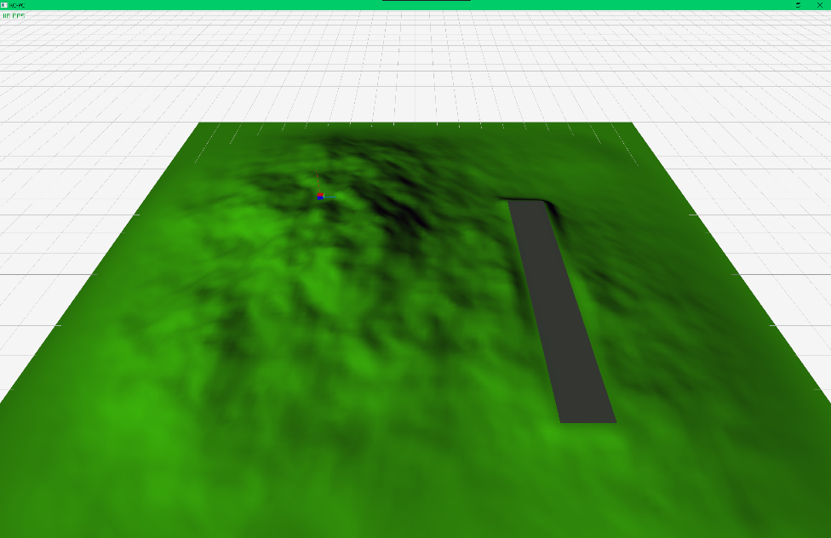

## Project Proposal

#### Title: RC-PC

#### Language: C++

### Overview:

* Use of OpenGL for 3D rendering
* Inputs from joystick type controllers
* Definition of file formats to store aircraft .aircraft (.zip file)
  + Contains the .obj
  + Contains UV and texture data
  + Contains a self-defined .bfp (.xml file) to store pre-baked flight profile arguments
* A method of editing the files

### Potential to add complexity

* Shaders
* Performance
* Calculate flight characteristics based on the 3D model file for use with the physics engine
* Editor for the new file types
* Support for the use of a VR headset using OpenVR

### Suitability

* 3D rendering and physics engine for flight should provide complexity
* Definition of file formats, reading and writing will add file handling
* Physics engine for the flight aspects will add physics beyond the rigid body engine built into one of the libraries I will use
* Interaction with different input devices will add the need for a number of configuration menus

### Success criteria

* Aircraft is simulated using predefined/pre-baked characteristics from a file
* Aircraft is controlled using an input device besides a keyboard and mouse
* Aircraft is rendered in full colour from a .obj and related texture files
* Flight control surfaces can be moved and are animated beyond the simulation
* Users can follow documentation and be able to create their own .aircraft files using a .obj from Blender

### Documentation

* Use of GitHub for versioning
* Use Obsidian note taking software for documentation

## Analysis

### Overview

#### A market gap for a model flight sim

The available flight sims currently on the market are designed with full scale aircraft in mind, making them unsuitable for people wishing to increase their flight hours on model aircraft.

All currently available model flight sims are either designed for Windows XP or require proprietary hardware.

A modern flight sim designed on a base of OpenGL 4.0 will provide full performance on modern hardware and sufficient resolution for flying a model aircraft.

To fill this market gap, the sim will need to have sufficient game textures available to approach the detail of a modern sim and sufficiently accurate physics to act as practice for flying read model aircraft.

##### Extracted points

* RC-PC will be a model aircraft flight simulation.
* It is intended as both a game and a realistic simulator.
* To fit as a game, it may be beneficial to add some form of competition
* It should be capable of allowing a user to create their own aircraft.
* This process should be possible using only knowledge of Blender.
* It will be built in C/C++ using OpenGL

##### Points to research

* OpenGL options in C/C++
* Physics of flight

#### Stakeholders

My stakeholders will include: - People interested in simulators as games (a similar demographic to Microsoft Flight Sim) - A simulator with a range of features beyond an accurate physics engine - A lighter flight sim or one with options which allow the application to run without requiring cutting edge hardware would be preferable for this market to allow a wider demographic - A mostly seamless experience without needing to fiddle with settings for setup - A range of pre-made aircraft, preventing the need to understand how to define their own - A multiplayer aspect would be preferable to fit this demographic, though adds significant complexity with the need for a fast server along with a domain - People interested in realistic simulation for flight practice - Mainly focused on the accuracy and realism of the simulator - Completely robust through all orientations and movements - Tools to represent their own aircraft in the sim

As such, I intend to ask several people within these groups to test the application during testing and once complete to gain an understanding of the success and areas for improvement.

##### Stakeholder requirements

* A flight sim to satisfy the requirements of a practice sim and an enjoyment sim
* Interactive process
  + Create or load aircraft
  + Load aircraft into a map
  + Connect a controller or other input device
  + Fly the aircraft within the map
  + Exit to a menu to load another aircraft or map, or receive input from a different device, or configure the sim or input device
* This interface will require not only a 2D menu renderer and interface, but also a 3D renderer and paired interface
* It should be possible to use as wide a range of input devices as possible, allowing for not only the use of dedicated flight control hardware, but also mouse and keyboard prevents limiting the number of users

##### Usage

* Inputs and outputs from each of the parts of the application:
  + Flight
    - The flight part of the application will require the 3D model of the aircraft, the pre-calculated physics of the model and a map model
    - This will need to output an image of the 3D world to the user from a toggleable mode camera to allow customisation
  + 2D Menus
    - Graphics settings
    - Input bindings and control regimes
    - Aircraft selection
    - Exit, resume and aircraft editor buttons
    - Weather options
  + Aircraft editor
    - Loading .obj: either drag into the window, or load through a file explorer
    - Enter values for the animations and bones for debugging
    - Option to edit the physics values directly; some of these, such as thrust, will need to be edited manually regardless

##### Meeting stakeholder requirements

* As a game: Modern graphics with the performance to run on most systems Variety of built-in quality models; remove the need to spend too much time to get the best experience from a casual perspective Stable: stakeholders looking to play as a game will want the application to be stable and not require any modification to make it run on their system. This is best achieved with a standard framework, as this will have industry tools that will allow the application to be run on a multitude of architectures
* As a flight simulator: Simulator quality flight physics to allow use of the simulator as a substitute for real practice Variety of specialist input devices to allow the use of the most suitable, or currently owned by the stakeholder, one for the best experience for the user Ability to make their own aircraft models; this will allow more experienced and enthused users to import a model of any aircraft they may have built and be able to fly it in the sim

I also plan to ask some people outside of this target market to gauge usability and to possible add some form of tutorial - To expand this, the tutorial could try to detect the type of input device in use and tailor the information to fit the input device

#### First steps

* Build an application in C++ and OpenGL following tutorials to gain an understanding of the architecture
* Document the architecture to begin work on the application
* Research into the physics of flight to understand what inputs would be required for directly input properties or properties calculated from a .obj
* Research the scope of full CFD on an arbitrary .obj file

#### Potential Expansions

If I find time to add more features, I would like to add support for OpenVR to allow the use of VR headsets with the application to assist with immersion in the sim.

If possible, it would also be preferable to try to find a way of fully, or at least partially including the CFD in the physics calculations each frame using a separate thread for the physics engine. This would improve the accuracy of the sim while maintaining the same, or similar, performance.

### Existing products and projects

#### RC Desk Pilot

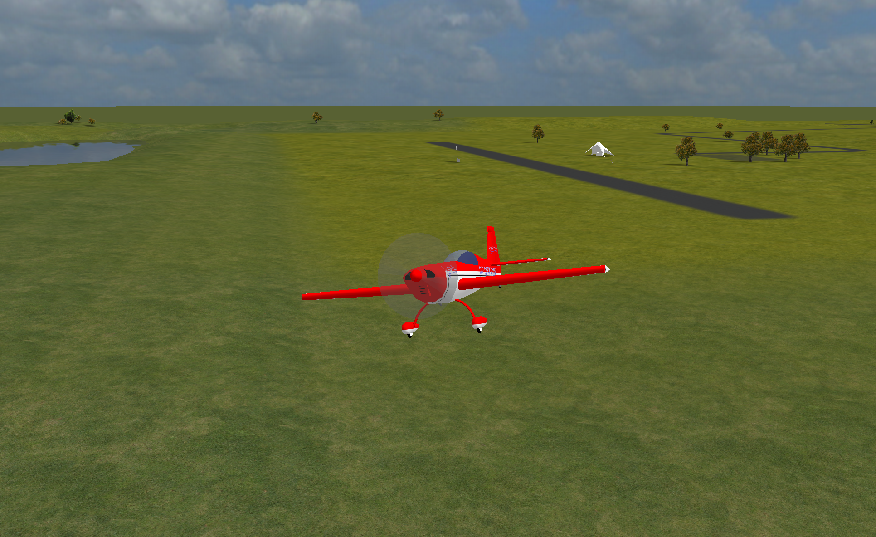

* Range of model aircraft available
* Tools to make your own aircraft
* Connects to a range of different controllers
* Weather features
* Sufficiently accurate physics

One of the major problems with RC Desk Pilot is the limitations imposed by the technology available when it began development; it is build using the DirectX platform and lacks any shaders that would be expected with a modern solution.

It also has a number of bugs and edge cases which have not been fully accounted for, partly due to its open-source nature and end of active development. There are a number of configurations which can result in unrealistic results from the physics engine.

###### Menu interface

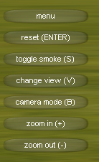

It has a simple and easy to use interface while managing to provide all of the options required for a flight sim. The button and menu design appears outdated, though also includes a number of novel features such as weather and other aircraft.

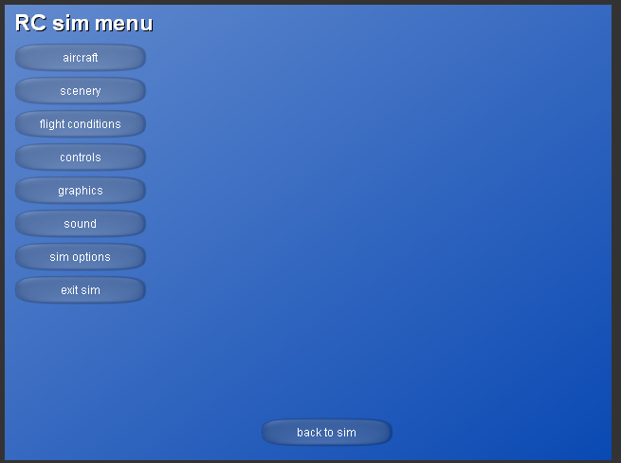

Many times, the sim will require use of the menus to even be able to connect and use a controller, as a keyboard cannot be used. While some controllers may simply work, many require knowledge of drivers and other hardware management systems. Fixing this from the perspective of the application would either require a refresh for the device selection list along with an explanation of the most common issues.

#### Microsoft Flight Sim 2020

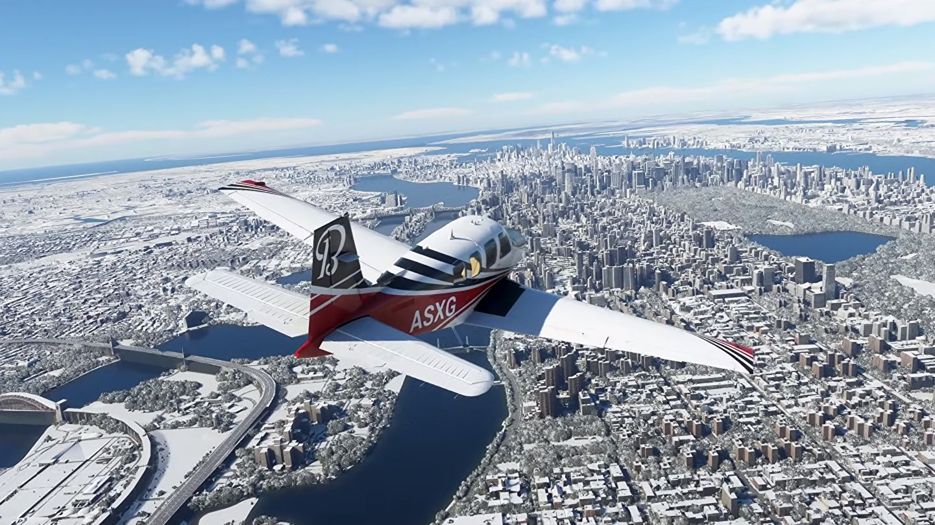

[image from “Rock Paper Shotgun”](https://www.google.com/url?sa=i&url=https%3A%2F%2Fwww.rockpapershotgun.com%2Fall-341-photorealistic-cities-in-microsoft-flight-simulator-2020&psig=AOvVaw2-aPVRGJ0CPWs3C3HYoOUM&ust=1636021274292000&source=images&cd=vfe&ved=0CAsQjRxqFwoTCKj1par8-_MCFQAAAAAdAAAAABAE) - Range of very detailed aircraft models available - Highly detailed environment - Unreasonably accurate physics and weather - Use of Windows libraries allows wide range of input device compatibility

Microsoft Flight Sim 2020 is the current flag ship product of the Microsoft Flight Sim line-up and is a fully furnished and refined product as would be expected from a Microsoft product.

The main issue with Microsoft Flight Sim 2020 for the problem I am trying to solve is, beside the almost triple A title cost, are the high hardware requirements for a decent experience.

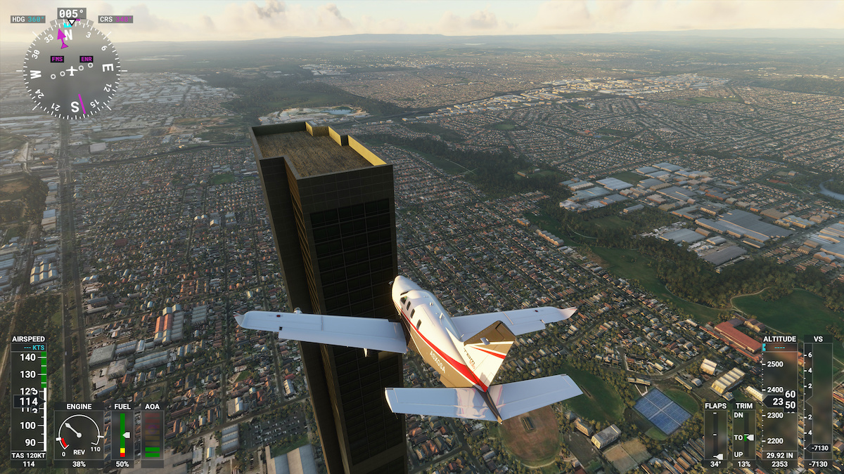

[image from Engadget](https://s.yimg.com/os/creatr-uploaded-images/2020-08/dcfd7710-e332-11ea-be8e-bfeddd85c18b)

Microsoft Flight Sim provides a huge number of options and input methods, while managing to maintain a clean and modern interface. This wide range of input methods ensures that different levels of difficulty and skill levels of users can be accounted for.

This huge number of options and features would be imposing for any new user, so ensuring that the sim will function without the need to browse these menus is important. This allows the user to explore the menus and features at their own pace.

#### Requirements to compete

* High quality models and rendering
* Detailed environment
* Accurate physics
* Wide range of compatibility
* Weather

Performance is also a major take away from this research, as it will need to run faster in some way than Microsoft Flight Sim while still completing with modern graphics and physics.

To complete in terms of performance, I will need to make use of a modern 3D rendering library to ensure that I do not spend the entire project only on optimising a subpar implementation.

### Features

* Pre-made models available
* Tools to make new models
* Loading these models
* Animation of these models with the input
* Compatibility with several input devices (including keyboard and mouse)
* Accurate physics while maintaining performance
* Reasonable environment and graphics

### Implementation

I have considered a variety of language for this program and have decided to use one of the languages from the C family of languages due to their native support for OpenGL based libraries.

Among the other languages I considered where Java and Python: As an interpreted language, Python would likely have been much too slow for any full 3D rendering without large amounts of time dedicated to optimising code and finding the most efficient implementations While Java does have a few OpenGL libraries available, having worked with one in the past (Aparapi), I concluded that its use in 3D rendering would have required implementing the full 3D rendering process as it is not designed as a graphics engine. Another option would be to use Vulkan or DirectX, both are less well documented as a result of the relative popularity of OpenGL

* OpenGL based rendering with C/C++/C#
* Using pre-baked physics to remove the need for real time CFD
* GLFW input (or XInput for extra compatibility) API
* Models stored and loaded from a custom file format
* Using CMake for compiling and linking
* Use of vcpkg (a package manager for use with CMake) to manage the required libraries

#### Update to implementation

After initial testing of the previous implementation technique, I found the use of CMake to be too unwieldy and overly complicated for what I required

As such I have switched to using mingw-make as the compiler which removes many features I do not need

* OpenGL based rendering in C/C++ using RayLib as an API
* Using pre-baked physics to remove the need for real time CFD
* RayLib contains libraries to function as interfaces for XInput or controller input interfaces
* Models stored and loaded from a custom file format

Having conducted a quick test of some examples, I have decided to use RayLib in C++ as it will provide access to similar performance to C along with the addition of fully supported OOP. Without RayLib, I would need to directly interface with OpenGL, which is mainly written in C, while also debugging my own code in C++, adding significant complexity without adding much to the function or scope of what I can demonstrate.

I will be building the application for use on Windows; though should still be compatible for macOS and Linux, I will not be testing it on these operating systems as I do not have easy access to one to test and debug it on.

#### Limitations of implementation

* Fairly hardware intensive due to the full frame rate rendering, though this should be minimised using OpenGL which is an industry standard 3D render and graphics interface
* Pre-baked physics will be slightly inaccurate compared to a real time CFD simulation
* A full CFD would be impossible without it being the focus of the project, especially to attempt to make it run in real time

### Hardware requirements

* A computer capable of running an OpenGL application at a usable frame rate; this should include almost any computer from the 6 or 7 years and probably longer
* A compatible controller or keyboard and mouse
* A monitor with sufficient resolution to see an aircraft (exact resolution will depend on the user)
* The total size of the application should stay below 150MB with RayLib included, excluding aircraft models
* The project will be self-contained using RayLib, an OpenGL wrapper library that allows easier use of the OpenGL interface
* RayLib is the best C++ wrapper library currently available for OpenGL, making it one of the best 3D rendering wrapper libraries currently available
* I will be developing the project in [VSCodium](https://vscodium.com/) which gives syntax highlighting, error highlighting, suggestions, built in terminal, and debug features
* This results in a fully portable development environment, allowing me to make use of GitHub to store and version my code in a private repository

### Brief: success criteria

* Realistic flight performance of aircraft
* Can be controlled with a variety of different input devices
* Runs at least 30fps, preferably more than 60fps
* Runs with sufficient resolution to allow easy control of a distance aircraft
* Included or built-in tools to make new aircraft models

| Feature | Solution | Justification |
| --- | --- | --- |
| Accepted |  |  |
| 3D Rendering | RayLib OpenGL interface | RayLib provides a powerful and easy to use interface, which will reduce the time I need to spend on trying to implement pure OpenGL. It is also a requirement for a modern flight simulator. |
| 2D Menus | RayLib | The user will need to be able to modify and control may aspects of the 3D part of the application; this will provide a standard method for this. |
| Variety of Input Devices | RayLib & XInput | Ensure that as many different controllers are supported to allow as wide a range of users as possible. |
| Shaders | RayLib OpenGL | Shaders are a critical part of ensuring that the application doesn’t look outdated before it is even complete. |
| Physics | RayLib or hand coded | Required: this may end up as a quaternion implementation of standard physics, or as a CFD based simulator for better accuracy. |
| Tentative |  |  |
| Aircraft Creation | Editor built into the application | Allow personalisation of aircraft to give variety and the option for the implementation of a near real model of a real aircraft model. |
| Pre-baked physics | This will need to be fully hand coded | Full CFD or some abstraction of the results will be required for this, along with a wind tunnel type approach to gather the required data. |
| Animation | RayLib OpenGL | Required for the flight surfaces and moving parts of aircraft. |
| Rejected |  |  |
| VR Support | RayLib workaround | Not required by stakeholders and not natively supported by RayLib; would also add significant complexity in designing menus usable both with a mouse and in VR. |
| Real time CFD | Handcrafted implementation | Only required for hyper accuracy and would place a similar load as Microsoft Flight Sim 2020, which is not performant enough for my stakeholders. |
| Built in 3D editor | Recommend use of Blender | Not required to edit the aircraft models as Blender can be used to edit these which prevents the need for me to implement a full mesh editor. |

### Computational methods

Both the 3D rendering, and physics involved with flight can be abstracted down to lower poly models along with an argument-based physics engine rather than a real time flow simulator. This vastly reduces the complexity of the problem, allowing it to be run at reasonable frame rates on consumer hardware.

Concurrency of the physics and rendering will improve performance by splitting the two most intensive tasks into independent threads. As only the rendering thread needs access to the physics data, and not the other way round, the complexity is kept minimal for a large performance gain.

The pre-calculation of several of the physical values for how the aircraft flies is a form of caching, removing the need to be able to calculate these on the fly; without this, it is likely a large part of the GPU’s processing would be required to run a full CFD simulation, removing extra headroom for the rendering to expand into.

OpenGL handles the distribution of the 3D rendering to the GPU, reduce the complexity of 3D graphics. I will still need to provide the required models, textures and object locations to render the scene; the best solution here is to write a helper class that handles the object, animations, textures and data to make it easier to have multiple objects in the scene.

OpenGL makes use of a graphics pipeline by splitting the rendering and updating of object locations between the CPU and the GPU. This allows the CPU to prepare the data for the next frame while the GPU is processing the previous frame to display to the user.

## Design

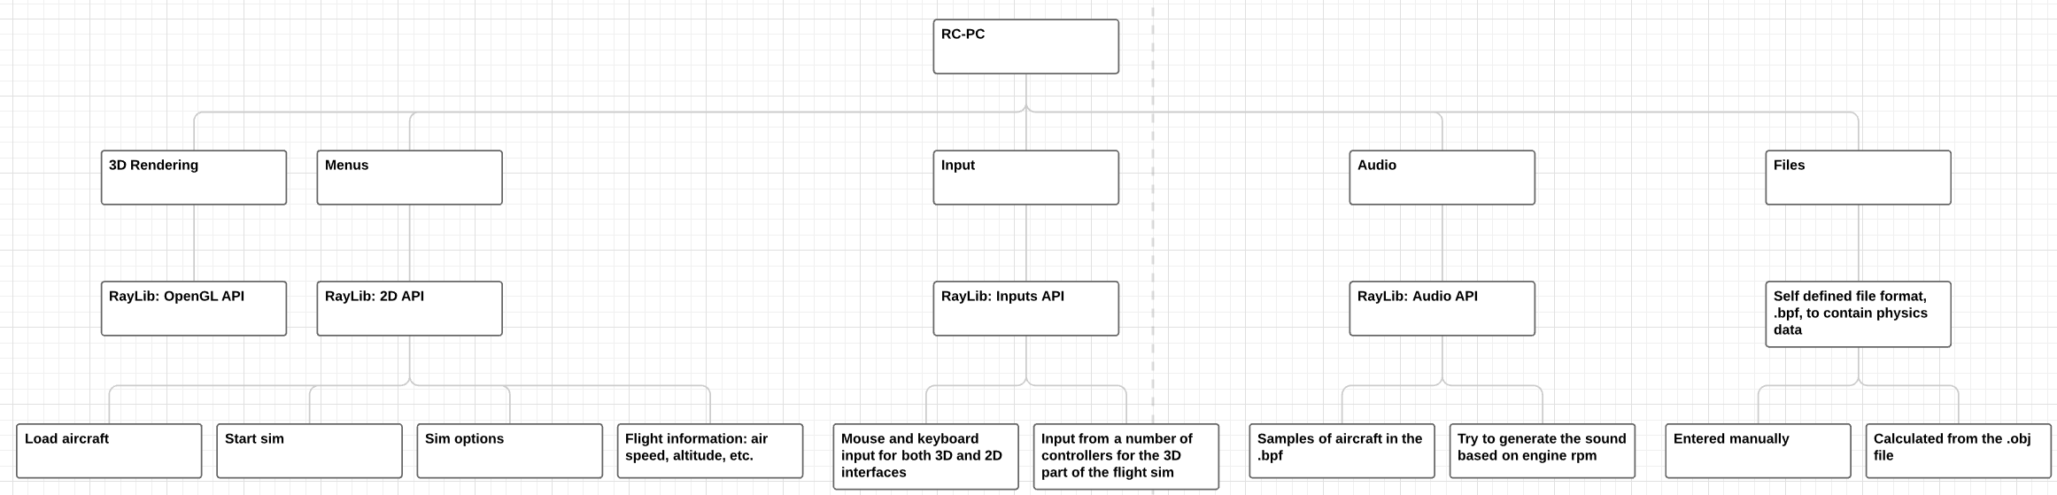

### Menus

#### Main Menu



* “Start Sim” button to open the location and plane select menu
* “Settings” button to open the settings menu
* “Exit” button to exit the application
* Use a render of the previous or default location as the background

#### Start Sim

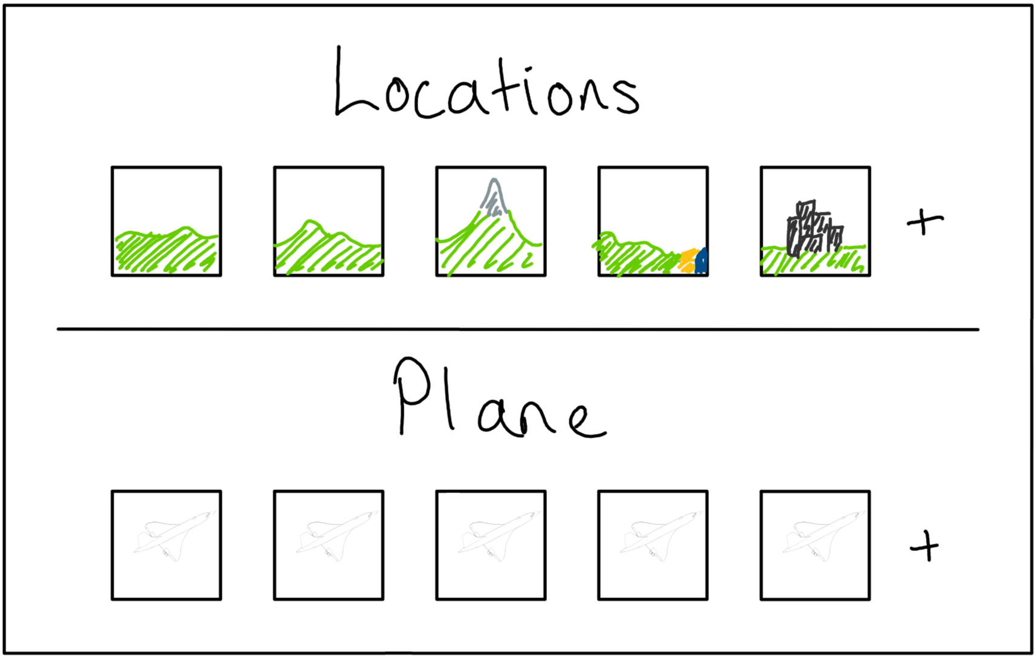

* Show most commonly used in order
* Select a location and plane
* Add level from .obj
* Add plane from custom format
* Same background as main, possibly with blur or reduced alpha

#### Settings

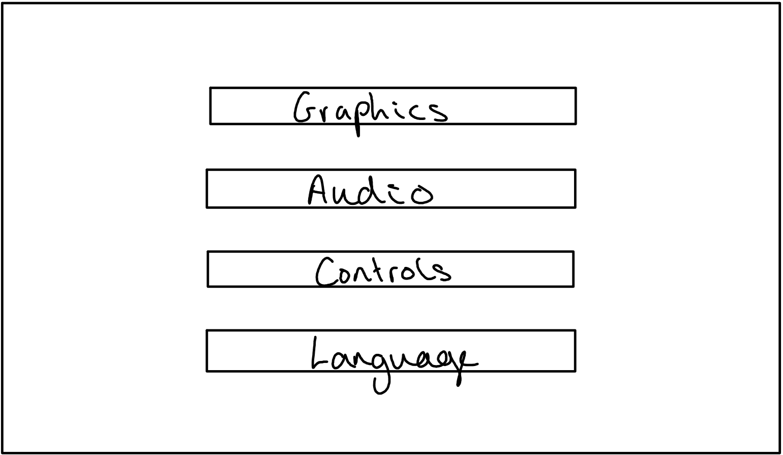

By reducing and fully categorising all available options

* Graphics
  + Texture quality
  + Model quality
* Audio
  + Audio device
  + Volume
* Controls
  + Input devices
  + Sensitivity
  + Channels
* Language?

#### 3D Simulator

* After selecting an aircraft and location, the simulator will be loaded
* This will be a rearrangement of the 3D scene used in the background of the menus
  + This will remove the need to either hide, or load, extra assets for the sim
  + This should help reduce load times into the sim once the application has been started

### Implementation

#### Renderer

Using C++ and OpenGL for the heavy lifting will reduce the need to focus on the required generic parts of any 3D software. As these two are also industry standards for use in 3D rendering, there should be sufficient documentation for understanding and developing with them.

OpenGL makes use of GLSL as its shading language; this will be used to the write the shaders run by the renderer to determine the colour of each pixel based on objects, textures, and colour maps.

#### Object files

Using OpenGL should allow the importing and displaying of .obj files with a bone structure for the active flight surfaces and other animation options, though this may add significant complexity.

The same .obj could be used for calculation of flight characteristic baking; the results of baking will need to be stored in a file format, probably an XML or JSON file. This calculating of flight characteristics will be well beyond the scope of this project to do fully, and will be best abstracted as a set of hand set variables describing the general performance of an aircraft. These variables can then be used as coefficients in the physics engine of the application.

[OpenGL Tutorial](http://www.opengl-tutorial.org/intermediate-tutorials/billboards-particles/particles-instancing/) [OpenGL Bones](https://learnopengl.com/Guest-Articles/2020/Skeletal-Animation) [GLSL Shaders](https://developer.mozilla.org/en-US/docs/Games/Techniques/3D_on_the_web/GLSL_Shaders)

##### Storing aircraft data

I would either need some way of linking the object file and the XML or JSON file containing the related flight data, or some custom file format to store both in a single file.

The simplest way of achieving this would be to store both the .obj file and the data file in a zip with a renamed file extension to allow easy searching of the files along with the benefit of available libraries in C++ for working with all three formats.

The major issue with making my own file format is the lack of tooling available without programming it myself for editing these files outside of reading them into the application; I would also need to write an editor for these files or not allow the user to make their own aircraft.

#### Physics

As the program is in C++, the physics engine shouldn’t require much optimising to reach the required performance compared to a language such as Python. The use of cofactors for the flight profiles of aircraft will also greatly simplify the physics engine without the need for complex CFD in real time.

In order of difficultly: 1. Direct coefficients on the input device axes 2. Manually entered flight characteristics - Inertia - Mass - Thrust 3. Auto calculation based on a 3D model - Thrust and mass would still need to be entered manually - Could use vertex weight painting to calculate inertia; my research for a [TVC-system](https://github.com/TommyGymer/TVC-system) should contain all the physics required for this

It is likely that something in between the first and second options will be sufficient for my requirements.

### Objects

#### Object class

| Variable | Datatype | Reason |
| --- | --- | --- |
| position | 3D Vector | for object location in 3D space |
| velocity | 3D Vector | to integrate to location in 3D space |
| acceleration | 3D Vector | to integrate to velocity; simplifies gravity |
| rotation | Quaternion | avoids gimble lock present in Euler implementations |
| angular velocity | 3D Vector | to integrate to rotation |
| scale | 3D Vector | for the x, y and z scale of each object |
| model | RayLib::Model | the model data: textures, meshes, etc. |

* Functions
  + Initialiser
    - Take a string from which to load the object data into the model attribute
  + Draw
    - Use the attributes to draw the object to the world
  + Update
    - Use numerical integration on the movement attributes

#### Vectors and Matrices

Use a 2D array to allow dynamic sizes of vectors and matrices Will need to consider how to invert / find the conjunction of square matrices; probably using an if statement and accounting for specific cases would be best

* Attributes
  + 1D element array
  + integer columns
  + integer rows
* Functions
  + Indexing
  + Basic arithmetic
  + Powers
  + Inverse
  + Normalise

#### Other

To make full use of the axis-angle rotation, quaternions will be required This will allow full use of angular velocity and accelerations

While RayLib already implements many of these, it may be beneficial to write my own vector and matrix lib to allow full use of all required overloads

### Algorithms

#### Vector and Matrix Maths Lib

* Simulating a 2D array using a 1D array



This will allow me to make use of a dynamic 2D array in C++ as there are no built-in structures to allow this







I will also need to be able to calculate a matrix inverse for rotating quaternions and normal vectors Doing this will require: - A function to produce the minor matrix from a matrix and element location within the matrix - A function to produce the full minor matrix - A recursive function to calculate the determinant of a matrix - A function to calculate the cofactors - A function to calculate the final inverse/transpose of the matrix



  
  




### Input Validation

* Combinations of keys: e.g. Ctrl, Shift, Caps Lock, etc.

### Unit testing

* Testing specific functions with specific test cases
* Set up test functions to be run at program start while in debug mode to test the basic functions of classes and functions

##### Testing the matrix class

| Function to test | Given input | Expected output |
| --- | --- | --- |
| Vector get | x: 7  y: 8  z: 9 | x: 7  y: 8  z: 9 |
| Vector set | x: 1  y: 2  z: 3 | x: 1  y: 2  z: 3 |
| Vector add | a.x: 1 b.x: 4  a.y: 2 b.y: 5  a.z: 3 b.z: 6 | c.x: 5  c.y: 7 c.z: 9 |
| Vector subtract | a.x: 1 b.x: 4  a.y: 2 b.y: 5  a.z: 3 b.z: 6 | c.x: 3  c.y: 3 c.z: 3 |
| Quaternion get | w: 9  x: 10  y: 11  z: 12 | w: 9  x: 10  y: 11  z: 12 |
| Quaternion set | w: 1  x: 2  y: 3  z: 4 | w: 1  x: 2  y: 3  z: 4 |
| Quaternion add | a.w: 1 b.w: 5  a.x: 2 b.x: 6  a.y: 3 b.y: 7  a.z: 4 b.z: 8 | w: 6  x: 8  y: 10  z: 12 |
| Quaternion multiply | a.w: 1 b.w: 5  a.x: 2 b.x: 6  a.y: 3 b.y: 7  a.z: 4 b.z: 8 | w: -60  x: 12  y: 30  z: 24 |
| Quaternion multiply with a negative | a.w: 0 b.w: 0.707  a.x: 1 b.x: 0  a.y: 0 b.y: 0.707  a.z: 0 b.z: 0 | w: 0  x: 0.707  y: 0  z: -0.707 |
| Quaternion rotate | b.w: cos(pi/4)  a.x: 1 b.x: 0  a.y: 0 b.y: sin(pi/4)  a.z: 0 b.z: 0 | x: 0  y: 0  z: -1 |
| Quaternion rotate continuity | b.w: cos(pi/4)  a.x: 0 b.x: 0  a.y: 10 b.y: sin(pi/4)  a.z: 0 b.z: 0 | x: 0  y: 10  z: 0 |
| Matrix multiply | a: $\left(\begin{matrix}1 & 0 & 0 \\ 0 & 1 & 0 \\ 0 & 0 & 1\end{matrix}\right)$ b: $\left(\begin{matrix}1 & 2 & 3 \\ 4 & 5 & 6 \\ 7 & 8 & 9\end{matrix}\right)$ | c: $\left(\begin{matrix}1 & 2 & 3 \\ 4 & 5 & 6 \\ 7 & 8 & 9\end{matrix}\right)$ |
| Matrix scale | a: $\left(\begin{matrix}1 & 2 & 3 \\ 4 & 5 & 6 \\ 7 & 8 & 9\end{matrix}\right)$ b: 2 | c: $\left(\begin{matrix}2 & 4 & 6 \\ 8 & 10 & 12 \\ 14 & 16 & 18\end{matrix}\right)$ |
| Identity matrix inverse | a: $\left(\begin{matrix}1 & 0 & 0 \\ 0 & 1 & 0 \\ 0 & 0 & 1\end{matrix}\right)$ | b: $\left(\begin{matrix}1 & 0 & 0 \\ 0 & 1 & 0 \\ 0 & 0 & 1\end{matrix}\right)$ |
| Arbitrary matrix inverse | a: $\left(\begin{matrix}-3 & 0 & -1 \\ 0 & 1 & 0 \\ 1 & 0 & 2\end{matrix}\right)$ | b: $\left(\begin{matrix}-0.4 & 0 & -0.2 \\ 0 & 1 & 0 \\ 0.2 & 0 & 0.6\end{matrix}\right)$ |

This testing is run at start-up of the program



This function outputs the debug results to the terminal if the boolean argument is set to true



This ensures that the class is functioning correctly before entering the main loop

## Developing a Coded Solution

### Setting up development environment



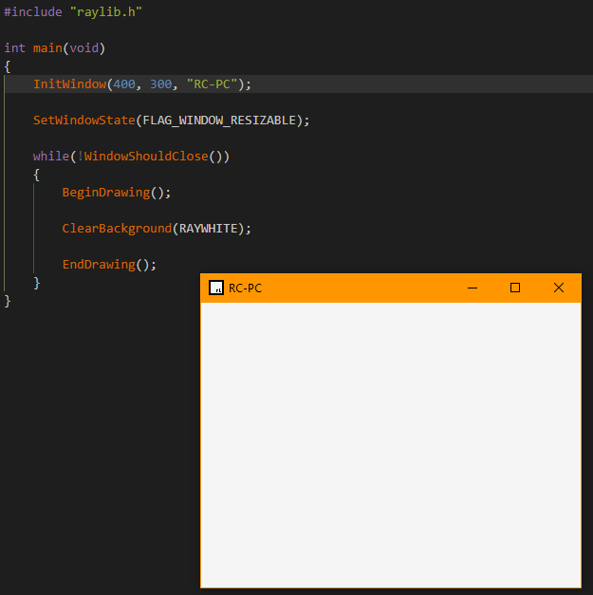

#### Setting up [VSCodium](https://vscodium.com/) to facilitate development

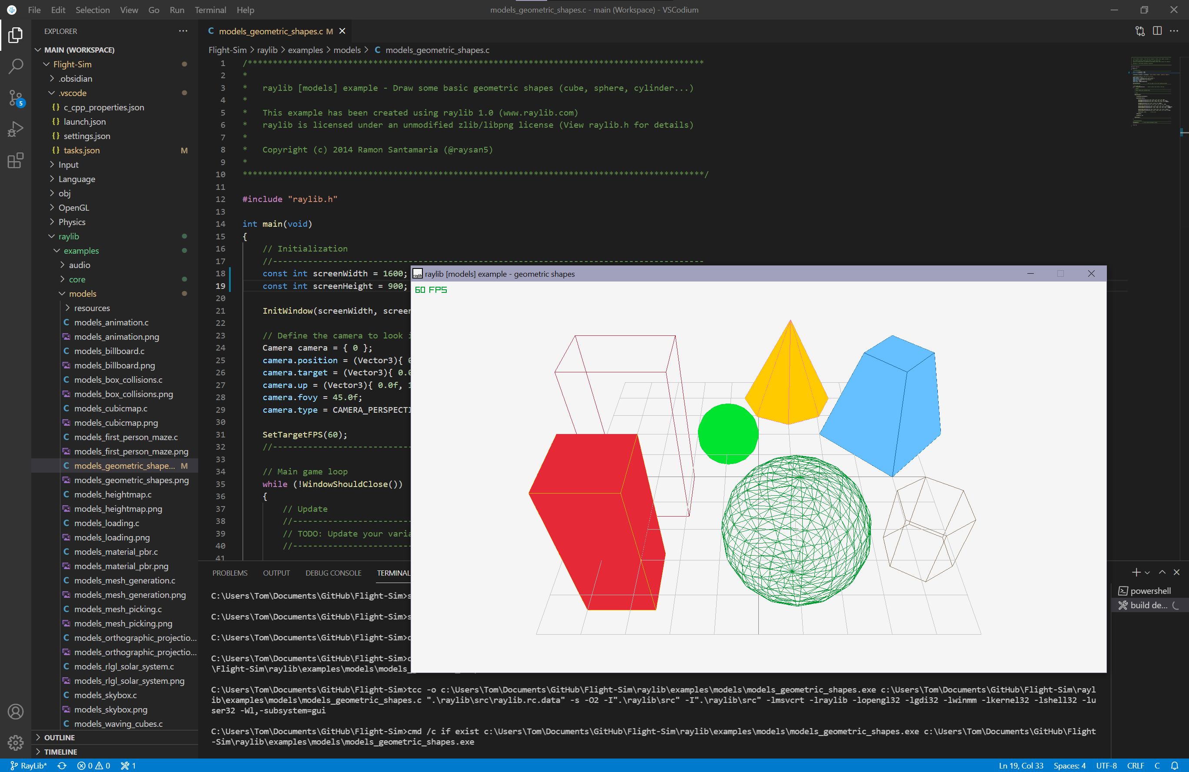

Added a shortcut to build and run the active file to allow for easier and quicker testing.

Above shows one of the RayLib examples I have used to test that the shortcut functions as expected.

#### First rendering

Due to my lack of previous experience with both OpenGL and C# for graphical rendering, I intend to first produce a simple application to learn how OpenGL can be used with imported .obj files and render them.

Once I have a better understanding of the architecture, I should be able to construct the application without the need for copying code directly.

I will be following an [OpenGL in C++](http://www.opengl-tutorial.org/beginners-tutorials/tutorial-1-opening-a-window/) tutorial to develop my first application in C++ and OpenGL. This covers the basics of C++ and OpenGL to be able render an object using shaders.

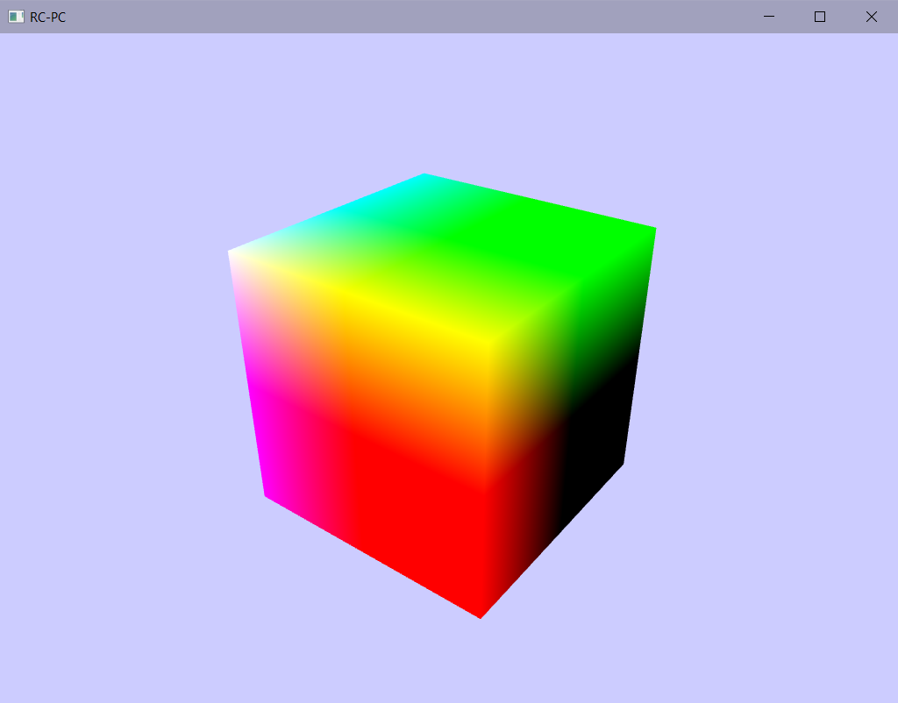

#### Loading from a .obj file

[Tutorial](https://ogldev.org/www/tutorial22/tutorial22.html)

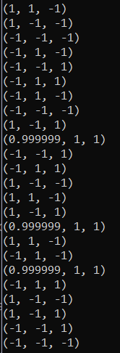

A .obj stores the points within the mesh of an object. These can be extracted form the file using Assimp and then loaded into the mesh array for the renderer.

### C++ rather than C

Using a port of RayLib to C++ will provide access to the OOP features that will help to formalise the structure of the program

As I will still be using RayLib and the change is only from C to C++, much of the code remains the same

#### Setting up C++

Starting with simply opening a window using C++ rather than C

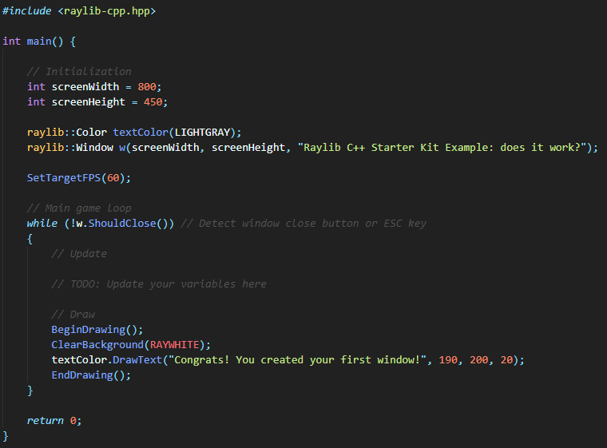

The above shows a demo I found which simply opens a windows and displays some text on it

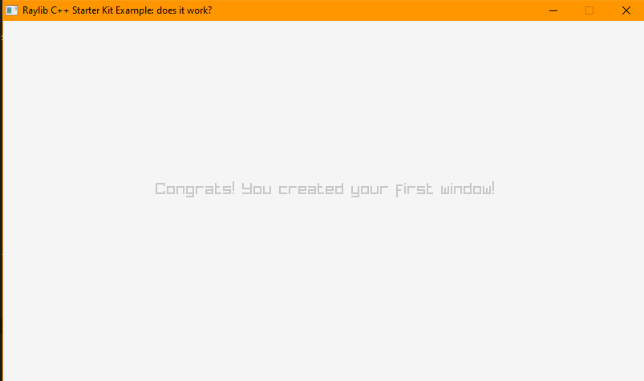

Allowing window resizing



#### Setting up 3D rendering

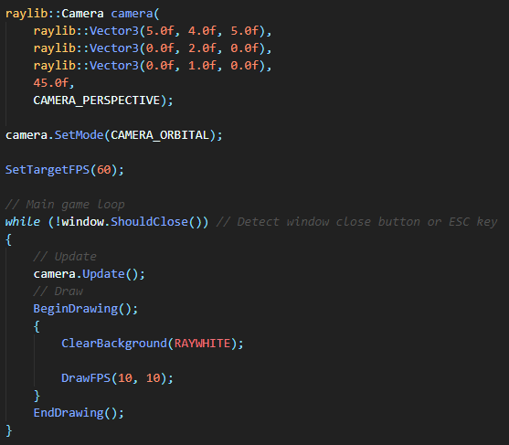

Not currently rendering anything: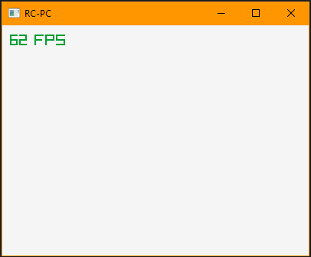

### Example shaders

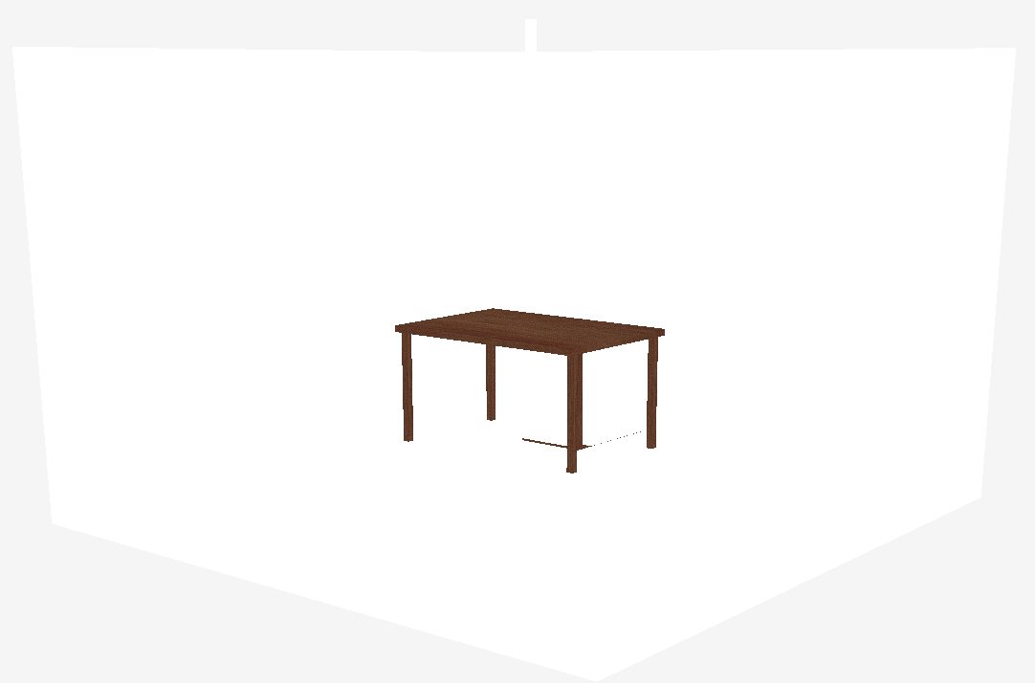

Testing one of the example shaders with an object made in Blender

### Shaders

[GLSL Tutorial](https://learnopengl.com/Getting-started/Shaders) [OpenGL Shader documentation](https://www.khronos.org/opengl/wiki/OpenGL_Shading_Language)

#### Fragment Shaders

Fragment shaders handle the shading of material in between vertices by either interpolating the vertex colours, or using a UV map

This is where ambient, diffuse and specular lighting and reflections are calculated

#### Vertex Shaders

Vertex shaders handle the rendering of vertices and their location within a UV map

They take the location of each vertex within object space and convert this to world space using the camera position and orientation

They also handle light location and normals for standard shading

### Object loading

RayLib contains helper methods for parsing .obj files and allows the easy import of a .obj and its related material files



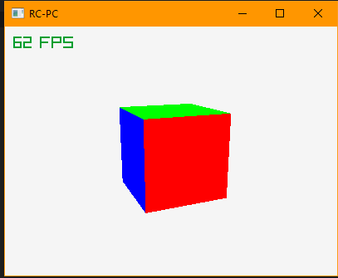

### Shaders

Shaders must then be set for each material to allow the renderer to know what to draw to the screen 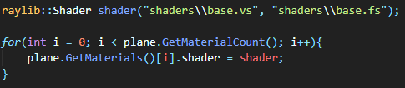 The object can then be drawn during the loop 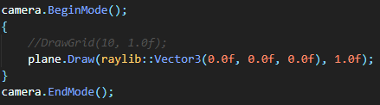

A grid can also be rendered to show y=0 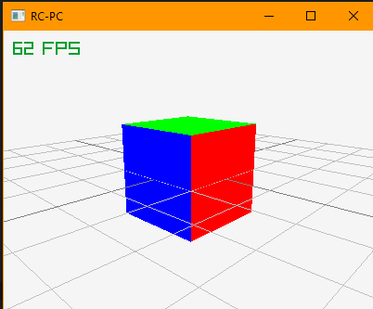

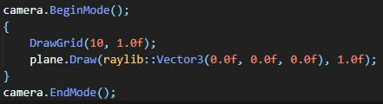

### Updating location during runtime

[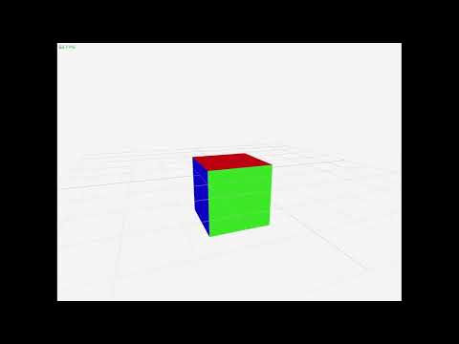](https://www.youtube.com/embed/LVGKkSuuQeI?feature=oembed)

 

By re-coding the start time of the program, the total run time can be determined This can then be used as a parameter of some function to determine location

### Object tracking

[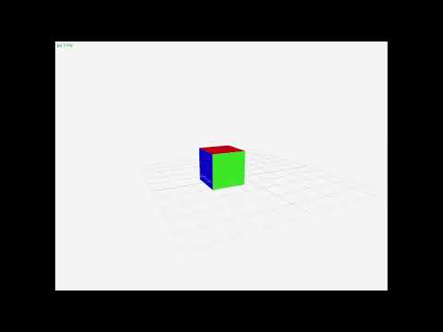](https://www.youtube.com/embed/ATTalhYqZVs?feature=oembed)

A more complex movement can be traced by changing all three x, y and z components of the object’s location

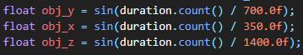

The object can then be tracked by pointing the camera at this location 

### Gravity

[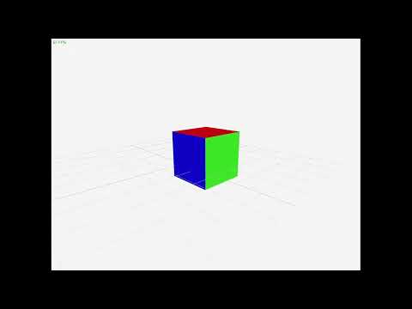](https://www.youtube.com/embed/axdAyFyHDnI?feature=oembed)

Gravity can then be implemented using a SUVAT and the total elapsed time 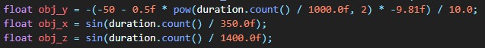

### Moving the model data to an object

[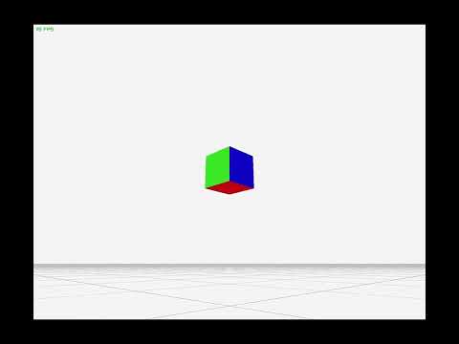](https://www.youtube.com/embed/7_r2Hc1Z5eM?feature=oembed)

Now making use of an object class and instancing to keep track of objects and render them This will help keep the code clean, as it removes the need to hard code each object required

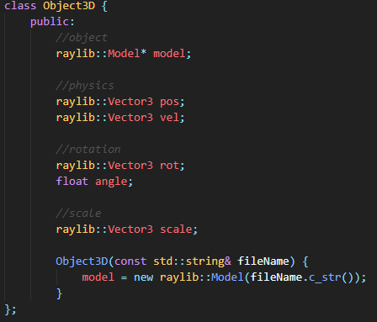

Object definition

| Variable name | Type | Usage |
| --- | --- | --- |
| model | raylib::model* | mesh and material data for the object |
| pos | raylib::Vector3 | location of the object in 3D space |
| vel | raylib::Vector3 | velocity of the object in 3D space |
| rot | raylib::Vector3 | axis around which to rotate |
| angle | float | the angle to rotate around the above axis |
| scale | raylib::Vector3 | scale factor of the model |

This initial design simply holds the data required for rendering the object

It would be better to implement a number of the required function which are currently within the main function into this class as any object that needs rendering would require them Many of these attributes would also have standard values, which would be useful not to need to initialize for every object

### Numerical integration

Rather than using a predefined SUVAT for movement, integrating an acceleration for velocity and then integrating velocity for position allows the changing of both acceleration and velocity during runtime

This can be easily achieved by tracking the previous frame time and subtracting this from the current time to find the change in time between the two frames This will make any physics based off this time entirely frame independent



The first version of this missed setting start to the current time at the end of dt, resulting in dt being found as the total time since the program started

[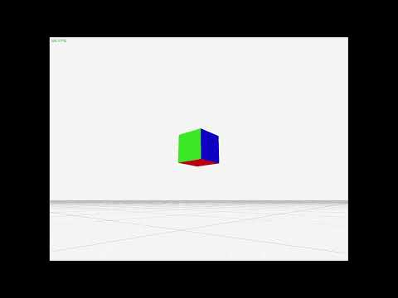](https://www.youtube.com/embed/X3skCgvnofg?feature=oembed)

### Moving per object functions to the Object class

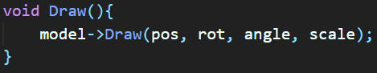

Moving the draw function to within the class allows the use of the local object variables without the need to first extract the required data for drawing from the object

This also allows for the code within the main loop to be kept simpler as each object only requires a single function call to draw

#### Per Object physics

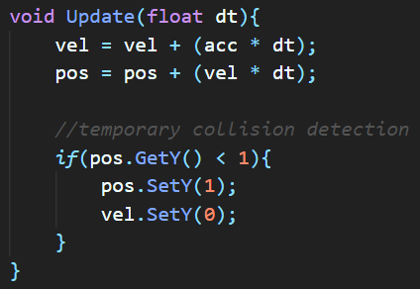

By moving the physics updating to a function, the code in the main loop can be further simplified to only require an update call and a draw call per object

This new implementation also features a collision detection with y=0 to allow the cube to stop falling at this plane

[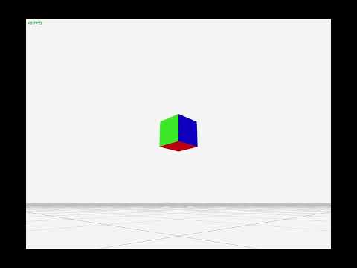](https://www.youtube.com/embed/eEFwRH3Ks08?feature=oembed)

### Quaternions

To fully represent the required rotations for a plane in 3D, quaternions are required

A Quaternion is defined as a 4D vector

$$\left(\begin{matrix}i \\ j \\ k \\ w\end{matrix}\right)$$

Where i, j and k can be imagined as a 3D vector with w as a rotation around this 3D vector

Each of these can take a value between -1 and 1; that is, a quaternion is a 4D unit vector

As raylib makes use of axis-angle, it is relatively simple to convert between quaternions and the format required by raylib

[source for below equations](https://www.euclideanspace.com/maths/geometry/rotations/conversions/quaternionToAngle/index.htm)

#### Quaternion to Axis-Angle

$$θ=2*arccos\left(w\right)$$

$$x=\frac{i}{\sqrt{1-w^{2}}}$$

$$y=\frac{j}{\sqrt{1-w^{2}}}$$

$$z=\frac{k}{\sqrt{1-w^{2}}}$$

#### Axis-Angle to Quaternion

$$w=cos\frac{θ}{2}$$

$$i=xsin\frac{θ}{2}$$

$$j=ysin\frac{θ}{2}$$

$$k=zsin\frac{θ}{2}$$

#### Multiplication

$$w=w_{1}w_{2}-x_{1}x_{2}-y_{1}y_{2}-z_{1}z_{2}$$

$$i=w_{1}x_{2}+x_{1}w_{2}+y_{1}z_{2}-z_{1}y_{2}$$

$$j=w_{1}y_{2}-x_{1}z_{2}+y_{1}w_{2}+z_{1}x_{2}$$

$$k=w_{1}z_{2}+x_{1}y_{2}-y_{1}x_{2}+z_{1}w_{2}$$

Raylib contains some helpers for working with quaternions, such as a quaternion to axis-angle conversion, but will require the implementing of some way to integrate a quaternion velocity and possible quaternion acceleration

 The above is the rotation quaternion within the object class

By modifying the draw function, the new quaternion representation of the rotation can be used

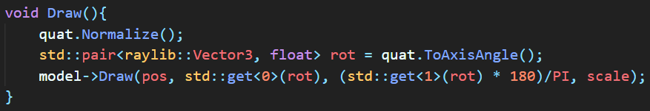

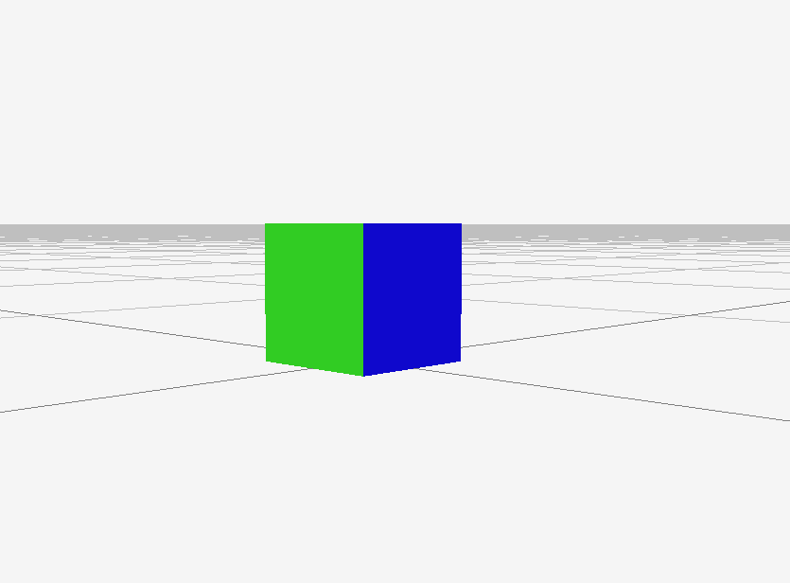

[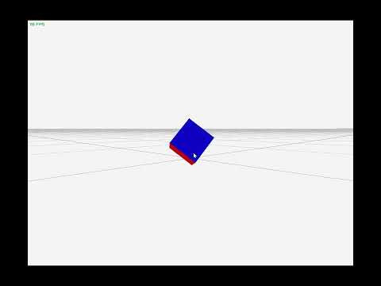](https://www.youtube.com/embed/dUCe0uEoomQ?feature=oembed)

Now able to rotate an object using an Euler 3D vector for angular velocity



Along with an integrator from the update angular velocity to the rotation quaternion

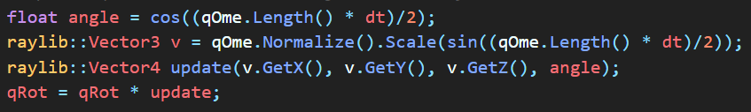

### Adding simple movement input

[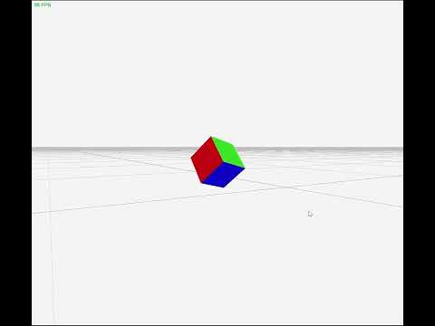](https://www.youtube.com/embed/loYukTZYObk?feature=oembed)

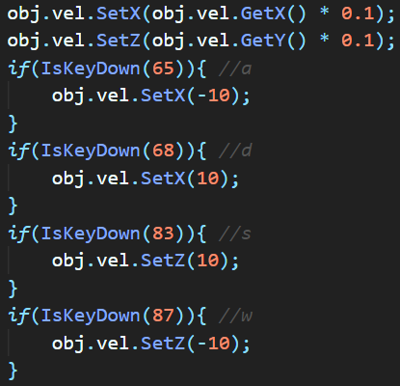

By damping the x-y velocity, an effect similar to friction can be achieved the velocity is set to a particular amount in a particular direction when one of the “wasd” keys is pressed As the velocity is already being integrated for position, the implantation of this user input is trivial

### First person

By moving the camera to the player object’s location and rotation, first person gameplay is achieved As both the object location and rotation are already available from the object, they can simply be set as the camera location and rotation

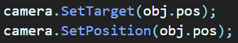

As the camera is set to the object’s location, the target can no longer be the object itself This will need to be a unit vector rotated by the quaternion to be in front of the camera

[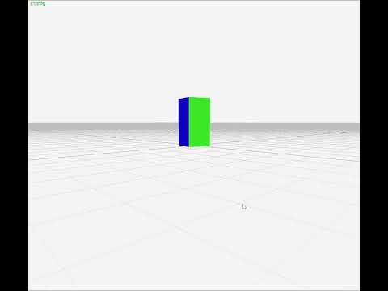](https://www.youtube.com/embed/Efajszzg8eQ?feature=oembed)

For debugging purposes, the camera target is set to another object’s location with is placed at the origin

#### Rotating the velocity with the quaternion

[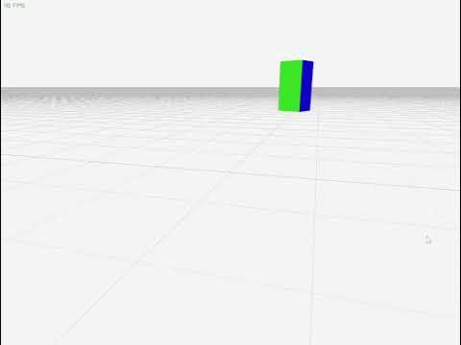](https://www.youtube.com/embed/G00l0dZQeGY?feature=oembed)

By rotating the velocity be the quaternion, the look direction of the camera can be kept consistent with the direction of movement caused by the keyboard input



In this case, for debugging, the object quaternion is set using the camera’s quaternion as this can be easily updated using the SetTarget function

### Making a matrix class

The matrix class begins with a simple double array and two integers to define the width and height of the matrix

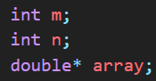

This will be the base data structure used to store all data about the matrix

A get and set function are required to translate an x, y position in the matrix into the required index in the double array

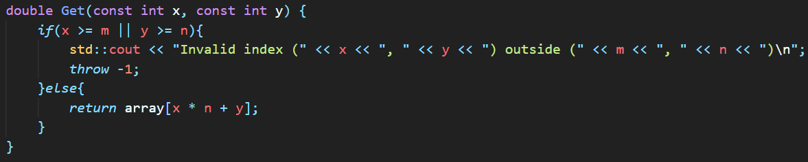

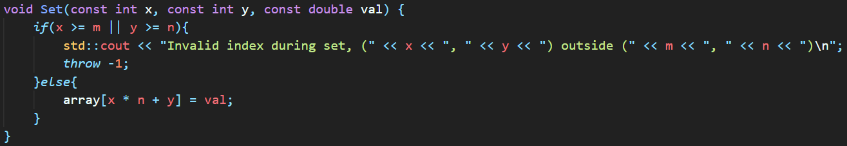

If the position is outside of the matrix, the function will throw an error after printing an out-of-bounds message

With these two functions, all matrix operations can be derived

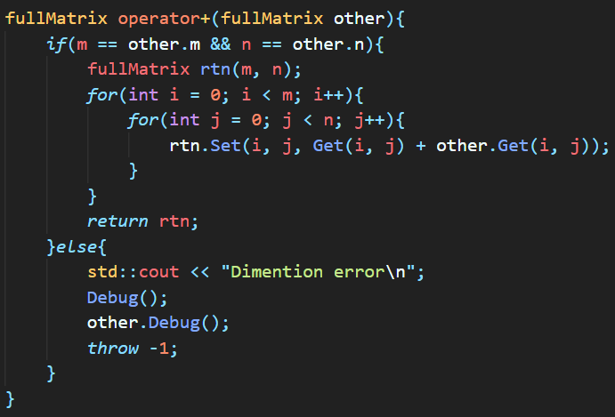

Until all functions shown in the algorithms section of Design are complete and tested

The raylib::Vector4 quaternion class currently in use appears to have some problems with my current aim which is to rotate the camera using the mouse for debugging rotation, movement and rendering

### Pointers

#### Working with the copy object constructor



When an object is passed into a function or returned from a function, the object is redeclared through the copy constructor

This caused a number of problems before I rewrote this function to correctly copy the attributes of the object. As the array was not being copied correctly, the data was lost seemingly without reason.

Making correct use of array copying gives:



As this avoids the need to understand how many bytes each of the elements is using, along with the number and values of the bytes used to keep track of the array size used during delete[] array.

After these changes, the matrix class can now be used for vector addition.

Further unit tests need to be written before the use of the rest of the functions to ensure they are working correctly before attempting to implement anything complicated.

The matrix class’s delete function, ~fullMatrix, simply calls delete[] on the object’s array. This is probably not necessary as this should be the default behaviour.

### Look vector camera movement



A look vector is defined in the object class and is updated in the update function



The camera can then target its position plus this look vector



Below is a demo of this

[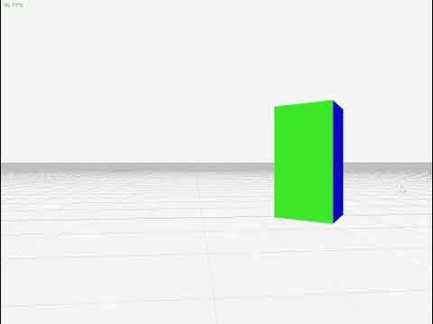](https://www.youtube.com/embed/506Yya9qHqQ?feature=oembed)

The camera is rotated with a and d with forward and backward motion on w and s

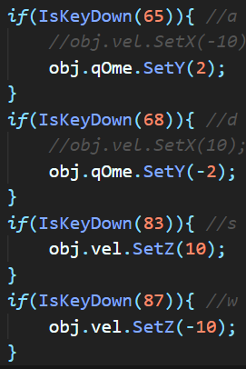

### Mouse input

First the mouse must be setup by hiding it

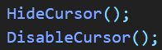

The change in mouse location is then calculated and a sensitivity factor is used The mouse is then moved back to the centre to allow the next mouse change to be calculated

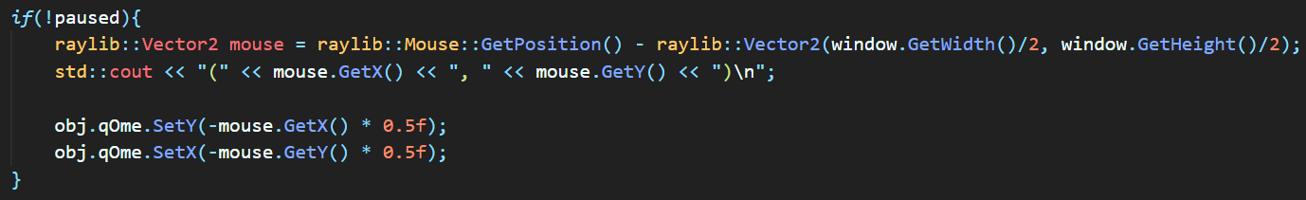

A pause button to allow moving the mouse away from the program

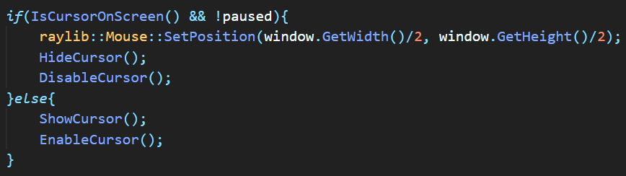

A pause toggle button is added to p

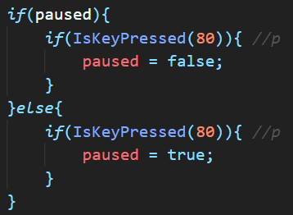

### Camera up vector

Currently, the object drifts as the velocity and acceleration are not being correctly rotated

Adding the camera up vector will allow easier debugging of this by displaying the problem



The up vector is defined within the object class



The up vector is updated within the update function

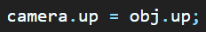

The camera up vector is then set to the object’s up vector

[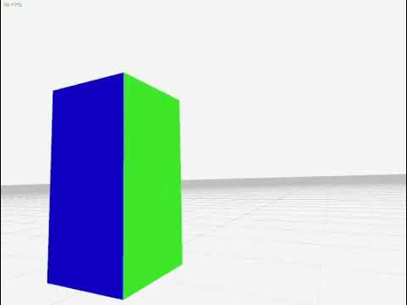](https://www.youtube.com/embed/WaluWrnCDfo?feature=oembed)

### Splitting classes into files

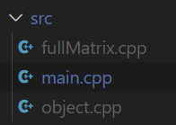

Splitting the classes into separate files will clean up the main file and make it easier to keep the code organized as it reduces the length of each individual file. This makes it easier to find and search for a particular bit of code as the general area can be found by knowing which class it is contained by.

### Replacing boolean game state with an Enum

This will allow easier reading as well as easy addition of new game states, such as main menu or other specific menu area



### Transferring physics to the matrix class

Most of the code remains the same beside the class names used at initialization

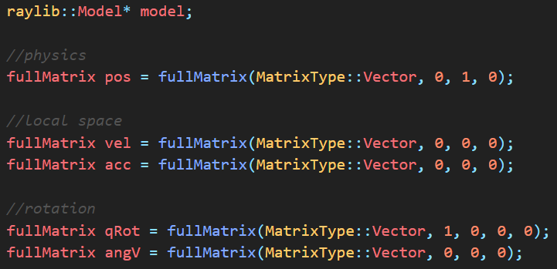

Now using an explicit definition of the update quaternion

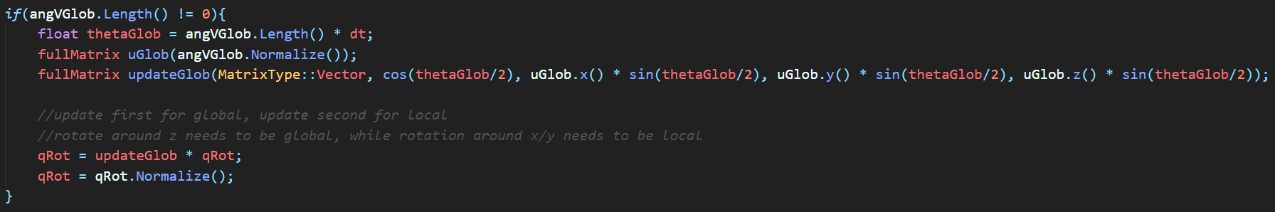

This also checks for a 0-length angular velocity which would result in a divide by zero error when normalizing if left

The formula for the update quaternion is from [this lecture from Stanford University](https://stanford.edu/class/ee267/lectures/lecture10.pdf)

### Correcting use of global and local space

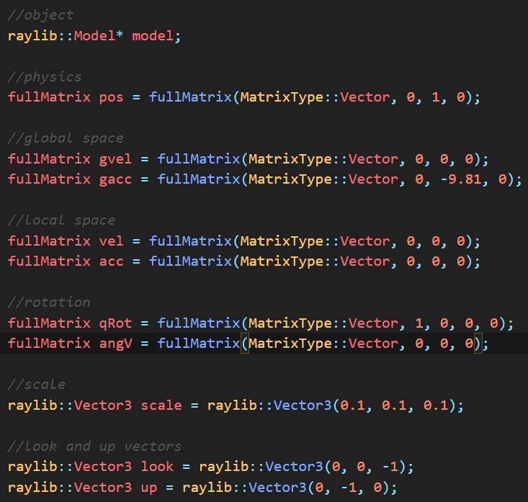

Added new global versions of acceleration and velocity to remove the reliance on the rotation quaternion and to reduce the time complexity



Splitting of the angular velocity into global and local movements allows the rotation required for use with a mouse

This solution also ensures that any combination of global and local rotation transformations can be easily tested and achieved

When used with a controller, most of the inputs will need to be local and the control surfaces of an aircraft act on along the axis of the plane

### Shaders

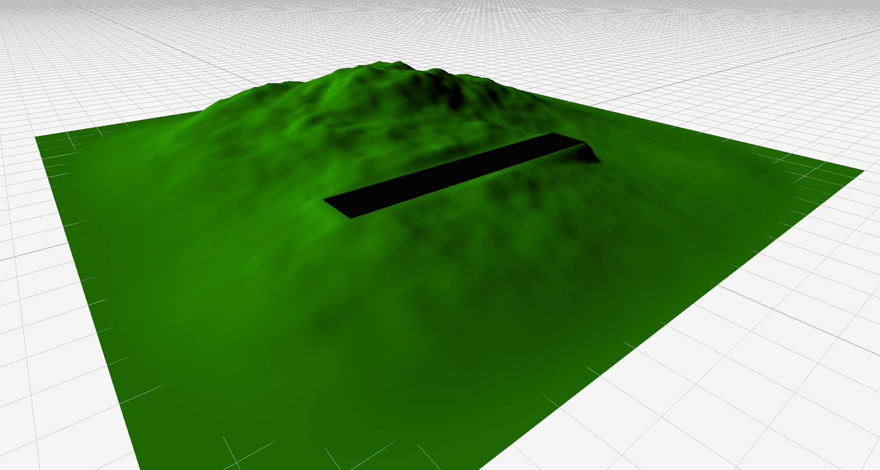

By using the dot product of the normal of the surface and a direction from which to project light, the surface can be coloured with an effect similar to shadows within a single convex shape



Scaling a shade of green with the dot product of the vertex and an arbitrary direction for the light source

### Shaders finished

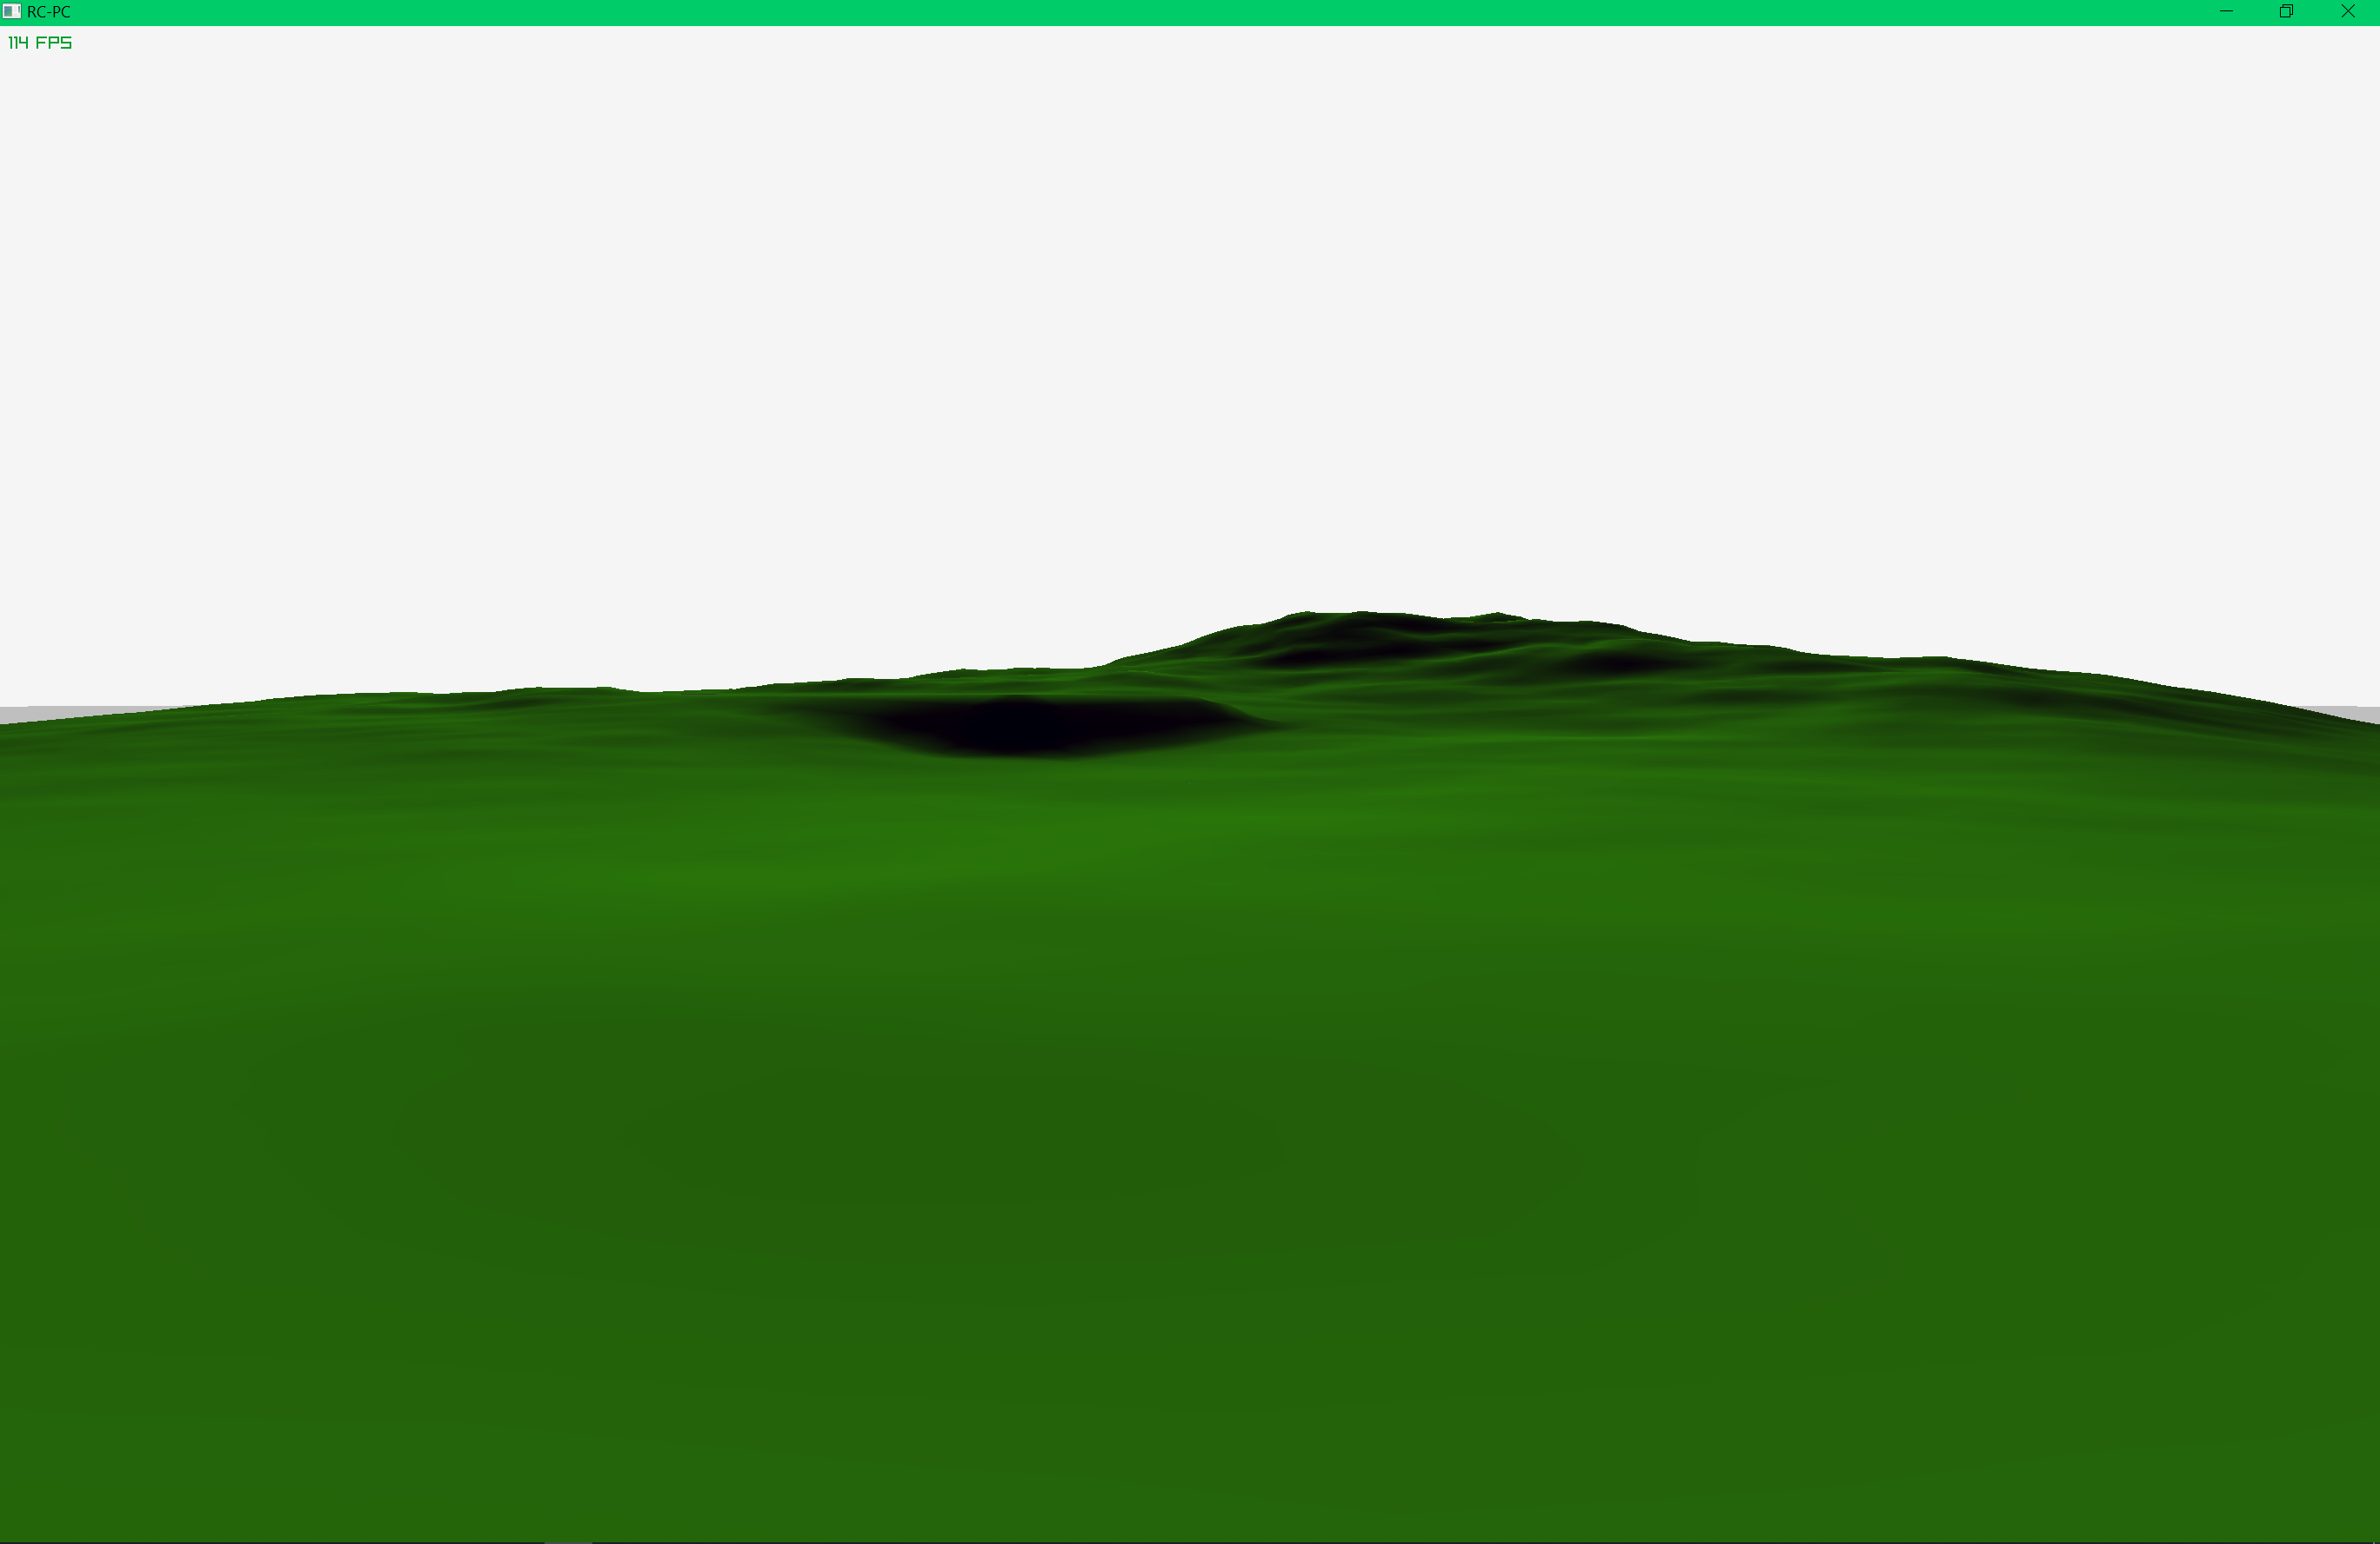

The shaders now simulate shadows relatively well with the runway correctly colourised

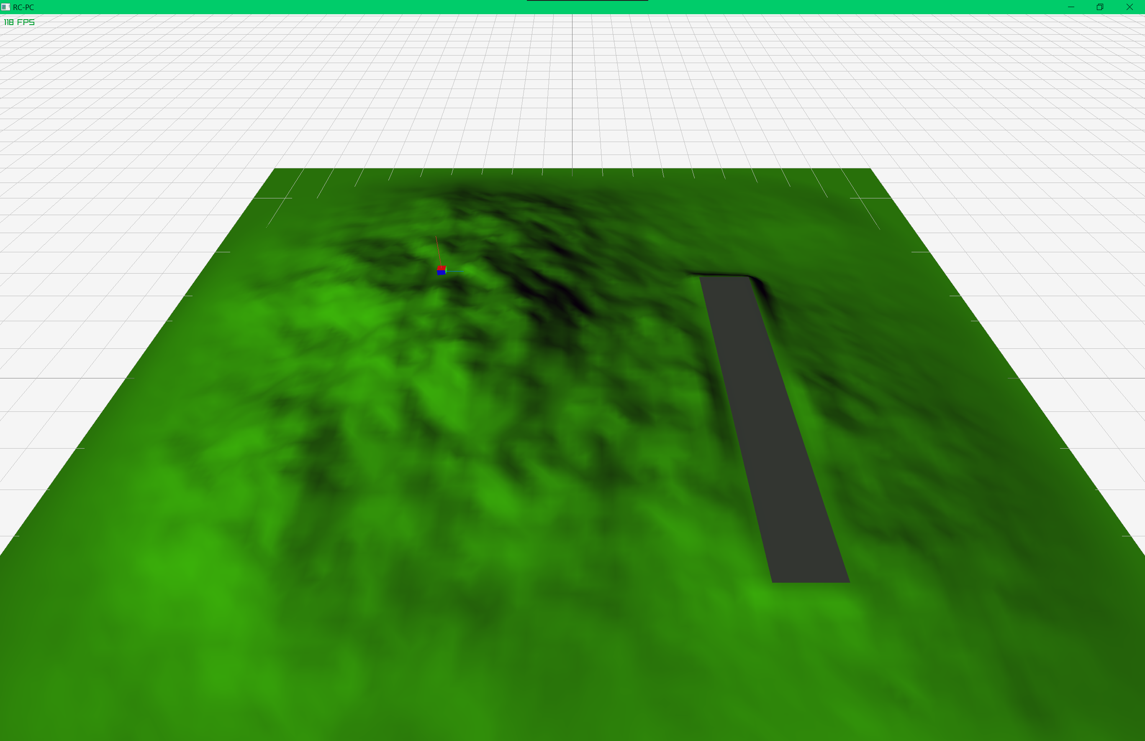

### Debugging an array deletion



The above debug log shows the use of the debug function in debugging an array deletion error in which an array used by an instance of the fullMatrix class is deleted more than once, resulting in an uncatchable crash

Problem found to be the result of using rtn = rtn * dA where rtn is the fullMatrix matrix containing the inverse matrix to be returned and dA is the inverse of the determinant of the matrix. This version appeared to result in the deletion of one of the required arrays while the version used while testing the fullMatrix * double function performed as expected. By changing over to using the version from the scale test, fullMatrix rtn(cofacts * dA), the inverse matrix function now performs as expected.

### Overloading the assignment operator

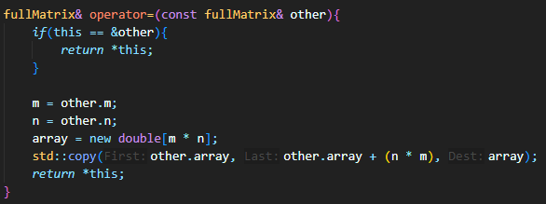

Explicitly defining the assignment (=) operator appears to have fixed many of the issues that randomly appeared while trying to debug the random crashes from the matrix testing

### New collisions

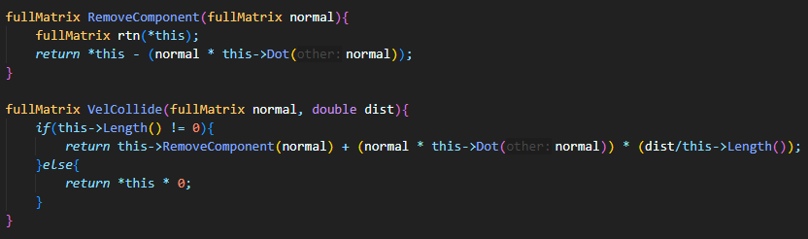

Now making use of a RemoveComponent function which removes the component of a vector which is parallel to the normal from a plane.

The VelCollide function contains and corrects the result from the RemoveComponent function.

### Menu

A 2D menu can be simply added using a 2D camera



Along with a menu game state to swap between the simulator and the menu



By defaulting the application game state to Menu, the application will start up in the menu

A background image containing the required buttons can then be added.

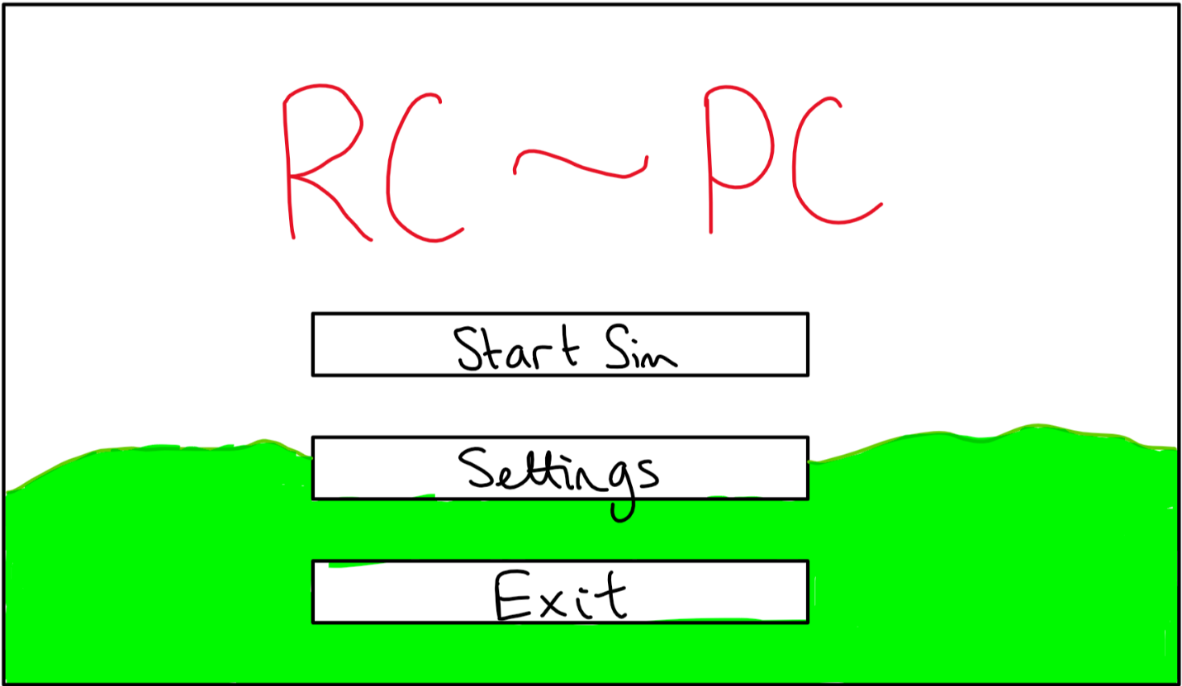





First, the window is defined as a RayLib rectangle which will be used in the scaling of the onscreen components.

Next, the game state is checked, if we are not in menu mode, the application will continue as normal. In menu mode, the cursor is ensured, and the location of the buttons is updated based on the size of the window.

The mouse position is obtained and each of the buttons is checked for a collision with the mouse. If the mouse is also clicked at the same time, the respective action is performed, i.e. exit the application for the “Quit” button, or start the simulator for the “Start Sim” button.

Finally, the background is drawn to the screen.

## Evaluation

### Collision evaluation

[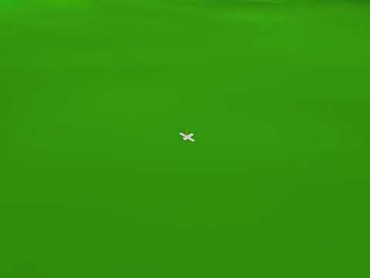](https://www.youtube.com/embed/XwenIVIofVU?feature=oembed)

Able to successfully detect and act on detected collisions; the main issue shown here is the velocity of the object which is set during the collision not being correct, not the detection of the collision. This would require further refinement in the velocity used when a collision is detected to allow smooth movement along the plane as well as setting the position to the plane.

This could be made much easier using a flat mesh rather than the shaped one in the video; however, this would greatly detract from the purpose of more complex graphics.

### Flight evaluation

[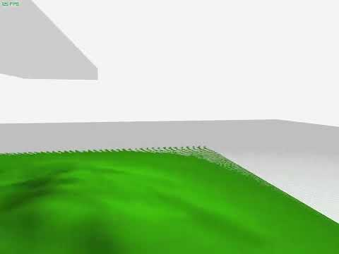](https://www.youtube.com/embed/DGzy_MFjXGQ?feature=oembed)

Able to move and rotate the airplane to simulate flight; the movement of the mouse is correctly interpreted into rotation of the camera, and the keyboard inputs are correctly interpreted into the movement of the camera. Requires further improvement to achieve an effect similar to the correct physics. The implementation of multi-axis input device support would be an effective way to debug any issues.

However, an input scheme would need to be deduced for use with a keyboard due to the boolean state of the keys, preventing smooth control.

The object shown along the top of the video is the aircraft object which correctly follows the camera.

### Integration

The application has been under continuous integration since the start, as this provides the simplest method to test all aspects of the code; without some parts of the program, other parts would either no function or be completely untestable.

The use of GitHub in this endeavour has been invaluable in managing the code base and tracking changes, ensuring that any change which does not perform as expected can be easily reverted to the most recent functional version.

### Testing the matrix class

| Function to test | Given input | Expected output | Passed |
| --- | --- | --- | --- |
| Vector get | x: 7  y: 8  z: 9 | x: 7  y: 8  z: 9 | 🗸 |
| Vector set | x: 1  y: 2  z: 3 | x: 1  y: 2  z: 3 | 🗸 |
| Vector add | a.x: 1 b.x: 4  a.y: 2 b.y: 5  a.z: 3 b.z: 6 | c.x: 5  c.y: 7 c.z: 9 | 🗸 |
| Vector subtract | a.x: 1 b.x: 4  a.y: 2 b.y: 5  a.z: 3 b.z: 6 | c.x: 3  c.y: 3 c.z: 3 | 🗸 |
| Quaternion get | w: 9  x: 10  y: 11  z: 12 | w: 9  x: 10  y: 11  z: 12 | 🗸 |
| Quaternion set | w: 1  x: 2  y: 3  z: 4 | w: 1  x: 2  y: 3  z: 4 | 🗸 |
| Quaternion add | a.w: 1 b.w: 5  a.x: 2 b.x: 6  a.y: 3 b.y: 7  a.z: 4 b.z: 8 | w: 6  x: 8  y: 10  z: 12 | 🗸 |
| Quaternion multiply | a.w: 1 b.w: 5  a.x: 2 b.x: 6  a.y: 3 b.y: 7  a.z: 4 b.z: 8 | w: -60  x: 12  y: 30  z: 24 | 🗸 |
| Quaternion multiply with a negative | a.w: 0 b.w: 0.707  a.x: 1 b.x: 0  a.y: 0 b.y: 0.707  a.z: 0 b.z: 0 | w: 0  x: 0.707  y: 0  z: -0.707 | 🗸 |
| Quaternion rotate | b.w: cos(pi/4)  a.x: 1 b.x: 0  a.y: 0 b.y: sin(pi/4)  a.z: 0 b.z: 0 | x: 0  y: 0  z: -1 | 🗸 |
| Quaternion rotate continuity | b.w: cos(pi/4)  a.x: 0 b.x: 0  a.y: 10 b.y: sin(pi/4)  a.z: 0 b.z: 0 | x: 0  y: 10  z: 0 | 🗸 |
| Matrix multiply | a: $\left(\begin{matrix}1 & 0 & 0 \\ 0 & 1 & 0 \\ 0 & 0 & 1\end{matrix}\right)$ b: $\left(\begin{matrix}1 & 2 & 3 \\ 4 & 5 & 6 \\ 7 & 8 & 9\end{matrix}\right)$ | c: $\left(\begin{matrix}1 & 2 & 3 \\ 4 & 5 & 6 \\ 7 & 8 & 9\end{matrix}\right)$ | 🗸 |
| Matrix scale | a: $\left(\begin{matrix}1 & 2 & 3 \\ 4 & 5 & 6 \\ 7 & 8 & 9\end{matrix}\right)$ b: 2 | c: $\left(\begin{matrix}2 & 4 & 6 \\ 8 & 10 & 12 \\ 14 & 16 & 18\end{matrix}\right)$ | 🗸 |
| Identity matrix inverse | a: $\left(\begin{matrix}1 & 0 & 0 \\ 0 & 1 & 0 \\ 0 & 0 & 1\end{matrix}\right)$ | b: $\left(\begin{matrix}1 & 0 & 0 \\ 0 & 1 & 0 \\ 0 & 0 & 1\end{matrix}\right)$ | 🗸 |
| Arbitrary matrix inverse | a: $\left(\begin{matrix}-3 & 0 & -1 \\ 0 & 1 & 0 \\ 1 & 0 & 2\end{matrix}\right)$ | b: $\left(\begin{matrix}-0.4 & 0 & -0.2 \\ 0 & 1 & 0 \\ 0.2 & 0 & 0.6\end{matrix}\right)$ | 🗸 |

As the program has no text input, there is little testing to do beyond ensuring that the program starts and runs will using different features, as shown in the collision and flight evaluation sections.

[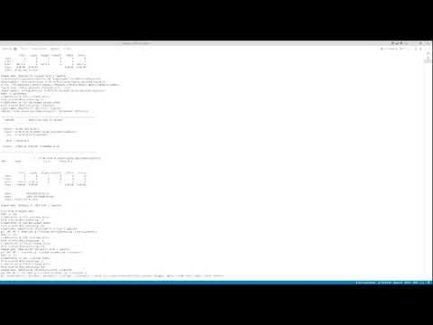](https://www.youtube.com/embed/1GZ9bd-rC70?feature=oembed)

The start of the log printed to the console is the output from the compiler with the “┏Testing fullMatrix” line denoting the start of the matrix testing. With the tests passing with “: checked”, the program then starts, and is closed shortly after.

### Menu evaluation

[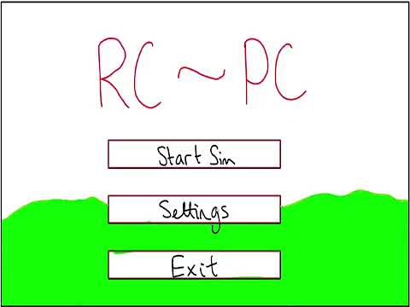](https://www.youtube.com/embed/yJHaNuWO81Y?feature=oembed)

With a functional “Start Sim” and “Exit” button, the menu is fully featured for the current features available within the simulator, as the additional features which might be controlled using the “Settings” tab are not implemented. The “Settings” button currently prints a “not implemented” message to the console.

### Comparing to success criteria

| Feature | Solution | Comments | Completed |
| --- | --- | --- | --- |
| Accepted |  |  |  |
| 3D Rendering | RayLib OpenGL interface | RayLib rendering is fully implemented with the ability to easily add new objects with an object class. | 🗸 |
| 2D Menus | RayLib | The menus are fully complete to the degree required to support the rest of the application. With new features, it would be worth expanding this with new button and label classes to ease menu development. | 🗸 |
| Variety of Input Devices | RayLib & XInput | Keyboard and mouse input supported, though requiring some more refinement.  RayLib provides a simple interface with which to implement further controller support. However, the current physics engine would likely not be able to make the most of the additional input axes. | Partial |
| Shaders | RayLib OpenGL | Shaders for the ground completed and a reasonable approximation for shadows added.  These could be worked on indefinitely, though the best improvement would be the proper use of the material data from the .mlt file pair with the .obj file for each object. | 🗸 |
| Physics | RayLib or hand coded | Hand coded and requiring more work before continuing any other features; this is the major source of issues with the current implementation. | Partial |
| Tentative |  |  |  |
| Aircraft Creation | Editor built into the application | Additional features could be added after physics has been fixed to an acceptable level.  The use of Blender allows easy importing of new models if access to the source code is available. | **-** |
| Pre-baked physics | This will need to be fully hand coded | The current physics are “baked” into the physics engine itself, and would require separating to the Object class. | **-** |
| Animation | RayLib OpenGL | Animation could likely be added fairly simply as RayLib provides an interface for this.  It would also require a .obj from Blender with animation in, however, which I do not have any experience with. | **-** |
| Rejected |  |  |  |
| VR Support | RayLib workaround | Additional features could be added after physics has been fixed to an acceptable level. | **-** |
| Real time CFD | Handcrafted implementation | Same as above: though this would provide a completely over-engineered solution to the problem. | **-** |

### Final evaluation

While not all the success criteria I had originally aimed for have been reached to the degree I had hoped, the application is usable and contains the full set of functionalities in an incomplete form; the physics engine is present and functional, but not sufficient for the game to be robust enough for the original purpose. This could be fixed with more work on the collision system and on debugging any glitches in the quaternion rotation system.

A few more classes could be added to more easily extend the menu, of which all the required code is already present and would simply need to be consolidated into an effective set of classes. With this, any new additions to the application could be easily added to the program in a similar way to adding new objects to the simulator (approximately 3 lines of extra code).

The keyboard and mouse input works as expected and would require a closer examination to find a control scheme which would optimise it for use in a flight sim. Most of the issues which appear to be from this part of the code are most likely bugs in either the physics or quaternion systems.